UNITED STATES
SECURITIES AND EXCHANGE COMMISSION
WASHINGTON, D.C. 20549

FORM 8-K

CURRENT REPORT
Pursuant to Section 13 or 15(d) of the Securities Exchange Act of 1934
Date of Report (Date of earliest event reported): August 06, 2026

PepGen Inc.
(Exact name of Registrant as Specified in Its Charter)

Delaware |  |  | 001-41374 | 85-3819886
(State or Other Jurisdiction  of Incorporation) |  |  | (Commission File Number) | (IRS Employer  Identification No.)
321 Harrison Avenue
8th Floor
Boston, Massachusetts |  |  |  | 02118
(Address of Principal Executive Offices) |  |  |  | (Zip Code)

Registrant’s Telephone Number, Including Area Code: (781) 797-0979

(Former Name or Former Address, if Changed Since Last Report)

Check the appropriate box below if the Form 8-K filing is intended to simultaneously satisfy the filing obligation of the registrant under any of the following provisions:
☐Written communications pursuant to Rule 425 under the Securities Act (17 CFR 230.425)
☐Soliciting material pursuant to Rule 14a-12 under the Exchange Act (17 CFR 240.14a-12)
☐Pre-commencement communications pursuant to Rule 14d-2(b) under the Exchange Act (17 CFR 240.14d-2(b))
☐Pre-commencement communications pursuant to Rule 13e-4(c) under the Exchange Act (17 CFR 240.13e-4(c))
Securities registered pursuant to Section 12(b) of the Act:
Title of each class |  | Trading  Symbol(s) |  | Name of each exchange on which registered
Common stock, par value $0.0001 per share |  | PEPG |  | Nasdaq Global Select Market
Indicate by check mark whether the registrant is an emerging growth company as defined in Rule 405 of the Securities Act of 1933 (§ 230.405 of this chapter) or Rule 12b-2 of the Securities Exchange Act of 1934 (§ 240.12b-2 of this chapter).
Emerging growth company ☒
If an emerging growth company, indicate by check mark if the registrant has elected not to use the extended transition period for complying with any new or revised financial accounting standards provided pursuant to Section 13(a) of the Exchange Act. ☐

Item 2.02 Results of Operations and Financial Condition.
On August 6, 2026, PepGen Inc. (the “Company”) announced its financial results for the quarter ended June 30, 2026 and other business updates and issued a press release titled “PepGen Reports Second Quarter 2026 Financial Results and Recent Corporate Highlights.” A copy of the press release is furnished as Exhibit 99.1.

The information in Item 2.02 of this Current Report on Form 8-K (this “Form 8-K”), including Exhibit 99.1, shall not be deemed “filed” for purposes of Section 18 of the Securities Exchange Act of 1934, as amended (the “Exchange Act”), or otherwise subject to the liabilities of that section, nor shall it be deemed incorporated by reference into any of the Company’s filings under the Securities Act of 1933, as amended (the “Securities Act”), or the Exchange Act, except as expressly set forth by specific reference in such filing.

Item 7.01 Regulation FD Disclosure.
On August 6, 2026, the Company updated its Corporate Presentation in connection with recent corporate updates, a copy of which is being furnished as Exhibit 99.2.
The information in Item 7.01, in this Form 8-K, including Exhibit 99.2, is intended to be furnished and shall not be deemed “filed” for purposes of Section 18 of the Exchange Act or otherwise subject to the liabilities of that section, nor shall it be deemed incorporated by reference in any filing under the Securities Act or the Exchange Act, except as expressly set forth by specific reference in such filing.

Item 8.01 Other Events.
On August 6, 2026, the Company announced that an independent Data and Safety Monitoring Board (the “DSMB”) has recommended advancing the ongoing Phase 2 FREEDOM2-DM1 study into the third and highest multiple ascending dose (“MAD”) cohort of 12.5 mg/kg, with no recommended changes to the study protocol. The DSMB also recommended dose escalation in the open-label extension (“OLE”) study from 5 mg/kg to 10 mg/kg. A copy of the press release issued in connection with the announcement is attached as Exhibit 99.3 to this form 8-K and incorporated herein by reference.

Item 9.01 Financial Statements and Exhibits.
d) Exhibits

Exhibit Number | Description
99.1 | Press release issued by PepGen Inc. on August 6, 2026 titled "PepGen Reports Second Quarter 2026 Financial Results and Recent Corporate Highlights"
99.2 | Corporate Presentation updated as of August 2026
99.3 | Press release issued by PepGen Inc. on August 6, 2026 titled "PepGen to Advance PGN-EDODM1 into Highest Dose Cohort in Phase 2 FREEDOM2-DM1 Study Following DSMB Review"
104 | Cover Page Interactive Data File (embedded within Inline XBRL document)

SIGNATURES
Pursuant to the requirements of the Securities Exchange Act of 1934, the registrant has duly caused this report to be signed on its behalf by the undersigned hereunto duly authorized.
 |  |  | PepGen Inc.
Date: | August 6, 2026 | By: | /s/ Noel Donnelly
 |  |  | Noel Donnelly, Chief Financial Officer

PepGen Reports Second Quarter 2026 Financial Results and Recent Corporate Highlights

– DSMB recommends advancement of PGN-EDODM1 into the highest dose cohort in the FREEDOM2-DM1 study, as well as FREEDOM-OLE dose escalation from 5 mg/kg to 10 mg/kg –

– 10 mg/kg FREEDOM2-DM1 cohort fully enrolled, with 7 of 8 participants having completed dosing; data expected in November –

– Results from 12.5 mg/kg FREEDOM2-DM1 cohort expected in 1H 2027 –
– Well-funded with $117.2M of cash as of June 30, 2026, sufficient to fund operations into the fourth quarter of 2027 –

BOSTON— August 6, 2026-- PepGen Inc. (Nasdaq: PEPG), a clinical-stage biotechnology company advancing the next generation of oligonucleotide therapies with the goal of transforming the treatment of severe neuromuscular and neurological diseases, today reported financial results for the quarter ended June 30, 2026 and recent corporate highlights.

"During the second quarter, our team maintained a strong focus on execution as we advanced FREEDOM2 and continued preparing for our next clinical data readout," said James McArthur, PhD, President and Chief Executive Officer of PepGen. "The DSMB's recommendation to dose escalate in both FREEDOM2 and the open-label extension reflects the encouraging safety profile of PGN-EDODM1 following several months of repeat dosing. We look forward to initiating enrollment in the 12.5 mg/kg cohort shortly and sharing data from the 10 mg/kg cohort in November. We remain confident that repeat dosing has the potential to build on the clinical foundation established in the FREEDOM single-ascending dose trial as we continue evaluating the safety and benefits of PGN-EDODM1 for individuals living with DM1."

Recent Program Updates

PGN-EDODM1: Myotonic Dystrophy Type 1 (DM1)
•
FREEDOM2 Phase 2 Multiple Ascending Dose (MAD) Randomized, Placebo-Controlled Clinical Trial of PGN-EDODM1:
o
PepGen has fully enrolled the 10 mg/kg MAD cohort of FREEDOM2, with 7 of 8 participants having completed dosing. Data from this cohort is on track to be reported in November.
o
Based on the review of available safety data from the 10 mg/kg MAD cohort and the open-label extension (OLE) study, an independent Data and Safety Monitoring Board (DSMB) recommended advancing the FREEDOM2 trial into the third and highest dose cohort (12.5 mg/kg). The DSMB also approved dose escalation in the OLE study from 5 mg/kg to 10 mg/kg. Read the full release here.
o
Results from the 12.5 mg/kg cohort of FREEDOM2 are expected in the first half of 2027. Pending results from Cohorts 2 and 3, PepGen plans to engage with regulators in an end of Phase 2 (EOP2) meeting to discuss plans for the registrational program.

o
Update from the OLE study is expected by early January. In the OLE, 6 of 8 participants from the 5 mg/kg FREEDOM2 cohort have elected to enroll, bringing total OLE enrollment to 16 participants.

Corporate Updates
•
In May 2026, PepGen presented a late-breaking oral and poster presentation featuring data from its PGN-EDODM1 program at the 15th International Myotonic Dystrophy Consortium (IDMC-15). The late-breaking oral session included analyses of individual patient mis-splicing data from the PGN-EDODM1 program, as well as natural history data characterizing mis-splicing in patients with DM1. Ahead of IDMC-15, PepGen's President and Chief Executive Officer, James McArthur, PhD, presented single and initial multiple ascending dose data for PGN-EDODM1 at the 6th Annual Pharma Day, co-hosted by Euro-DyMA and the Myotonic Dystrophy Foundation. Presentation materials are available on PepGen’s website under Scientific Publications. Read the full release here.

Financial Results for the Three Months Ended June 30, 2026

•
Cash, Cash Equivalents and Marketable Securities were $117.2 million as of June 30, 2026. Based on currently planned operations, PepGen believes that its existing cash, cash equivalents, and marketable securities will be sufficient to fund its operations into the fourth quarter of 2027.
•
Research and Development Expenses were $12.5 million for the three months ended June 30, 2026, compared to $18.4 million for the same period in 2025.
•
General and Administrative Expenses were $6.4 million for the three months ended June 30, 2026, compared to $5.5 million for the same period in 2025.
•
Net Loss was $17.8 million, or $(0.26) basic and diluted net loss per share, for the three months ended June 30, 2026, compared to $23.1 million, or $(0.70) basic and diluted net loss per share, for the same period in 2025. PepGen had approximately 69.3 million shares outstanding on June 30, 2026.
About PGN-EDODM1
PGN-EDODM1, PepGen's investigational candidate in development for the treatment of DM1, utilizes PepGen's proprietary EDO technology to deliver a therapeutic oligonucleotide that is designed to restore the normal splicing function of MBNL1, a key RNA splicing protein. PGN-EDODM1 addresses the deleterious effects of cytosine-uracil-guanine (CUG) repeat expansion in the dystrophia myotonica protein kinase (DMPK) transcripts which sequester MBNL1, by binding to the pathogenic CUG trinucleotide repeat expansion present in the DMPK transcripts and disrupting the binding between the CUG repeat expansion and MBNL1. PepGen believes this innovative therapeutic approach may have considerable advantages over oligonucleotide modalities that rely on knockdown or degradation of the DMPK transcripts as it will allow the DMPK transcripts to continue to perform their normal function within the cell, while also liberating MBNL1 to correct downstream mis-splicing events. The U.S. Food and Drug Administration has granted PGN-EDODM1 both Orphan Drug and Fast Track Designations for the treatment of patients with DM1. The European Medicines Agency (EMA) has recently granted Orphan Designation for PGN-EDODM1.
About PepGen
PepGen Inc. is a clinical-stage biotechnology company developing the next generation of oligonucleotide therapies with the goal of transforming the treatment of severe neuromuscular and neurological diseases. PepGen’s Enhanced Delivery Oligonucleotide (EDO) platform is founded on over a decade of research and

development and leverages cell-penetrating peptides to improve the uptake and activity of conjugated oligonucleotide therapeutics. Using these EDO peptides, PepGen is generating a pipeline of oligonucleotide therapeutic candidates designed to target the root cause of serious diseases.

For more information, please visit PepGen.com. Follow PepGen on LinkedIn and X.

Forward-Looking Statements
This press release contains forward-looking statements within the meaning of the Private Securities Litigation Reform Act of 1995, as amended. These statements may be identified by words such as “aims,” “anticipates,” “believes,” “could,” “estimates,” “expects,” “forecasts,” “goal,” “intends,” “may,” “plans,” “possible,” “potential,” “seeks,” “will,” and variations of these words or similar expressions that are intended to identify forward-looking statements. Any such statements in this press release that are not statements of historical fact may be deemed to be forward-looking statements. These forward-looking statements include, without limitation, statements regarding whether repeat dosing has the potential to build on the clinical data from the FREEDOM trial, expected timelines for data reports from our FREEDOM2-DM1 trial, including the 10 mg/kg MAD cohort of FREEDOM2 trial and dose escalated 12.5 mg/kg FREEDOM2 trial as well as the OLE trial for PGN-EDODM1, initiation of the 12.5 mg/kg FREEDOM2 cohort of the FREEDOM2 study, forecasts relating to PepGen’s cash runway, and ongoing and planned regulatory timelines and interactions.

Any forward-looking statements in this press release are based on current expectations, estimates and projections only as of the date of this release and are subject to a number of risks and uncertainties that could cause actual results to differ materially and adversely from those set forth in or implied by such forward-looking statements. These risks and uncertainties include, but are not limited to risks related to: delays or failure to successfully initiate or complete our ongoing and planned development activities for our product candidates, including PGN-EDODM1; our ability to enroll patients in our clinical trials, including FREEDOM2; that our interpretation of clinical and preclinical study results may be incorrect, or that we may not observe the levels of therapeutic activity in clinical testing that we anticipate based on prior clinical or preclinical results, including for PGN-EDODM1; our product candidates, including PGN-EDODM1, may not be safe and effective or otherwise demonstrate safety and efficacy in our clinical trials; adverse outcomes from our regulatory interactions, including delays in regulatory review, clearance to proceed or approval by regulatory authorities with respect to our programs, including clearance to commence planned clinical studies of our product candidates, or other regulatory feedback requiring modifications to our development programs, including in each case with respect to our PGN-EDODM1 program; changes in regulatory framework that are out of our control; unexpected increases in the expenses associated with our development activities or other events that adversely impact our financial resources and cash runway; and our dependence on third parties for some or all aspects of our product manufacturing, research and preclinical and clinical testing. Additional risks concerning PepGen’s programs and operations are described in our most recent reports filed with the SEC. PepGen explicitly disclaims any obligation to update any forward-looking statements except to the extent required by law.

This release discusses PGN-EDODM1, an investigational therapy that has not been approved for use in any country and is not intended to convey conclusions about its efficacy or safety. There is no guarantee that PGN-EDODM1 or any other investigational therapy will successfully complete clinical development or gain regulatory authority approval.

Investor Contact
Laurence Watts

New Street Investor Relations
laurence@newstreetir.com

Media Contact
Julia Deutsch
Lyra Strategic Advisory, LLC
Jdeutsch@lyraadvisory.com

Condensed Consolidated Statements of Operations
(unaudited, in thousands)
Three Months Ended
June 30,
 |  | 2026 |  | 2025
Operating expenses:
Research and development |  | $ 12,522 |  | $ 18,391
General and administrative |  | 6,417 |  | 5,541
Total operating expenses |  | $ 18,939 |  | $ 23,932
Operating loss |  | $ (18,939) |  | $ (23,932)
Other income (expense)
Interest income |  | 1,093 |  | 842
Other (expense) income, net |  | 50 |  | 3
Total other income, net |  | 1,143 |  | 845
Net loss before income tax |  | $ (17,796) |  | $ (23,087)
Income tax expense |  | (16) |  | —
Net loss |  | $ (17,812) |  | $ (23,087)
Net loss per share, basic and diluted |  | $ (0.26) |  | $ (0.70)
Weighted-average common stock outstanding, basic and diluted |  | 69,202,376 |  | 32,748,646
Condensed Consolidated Balance Sheets
(unaudited, in thousands)
 |  | June 30,  2026 |  | December 31,  2025
Assets
Cash, cash equivalents and marketable securities |  | $ 117,238 |  | $ 148,456
Other assets |  | 24,159 |  | 25,451
Total assets |  | $ 141,397 |  | $ 173,907
Liabilities and stockholders’ equity
Liabilities |  | $ 21,864 |  | $ 26,463
Stockholders’ equity |  | 119,533 |  | 147,444
Total liabilities and stockholders’ equity |  | $ 141,397 |  | $ 173,907

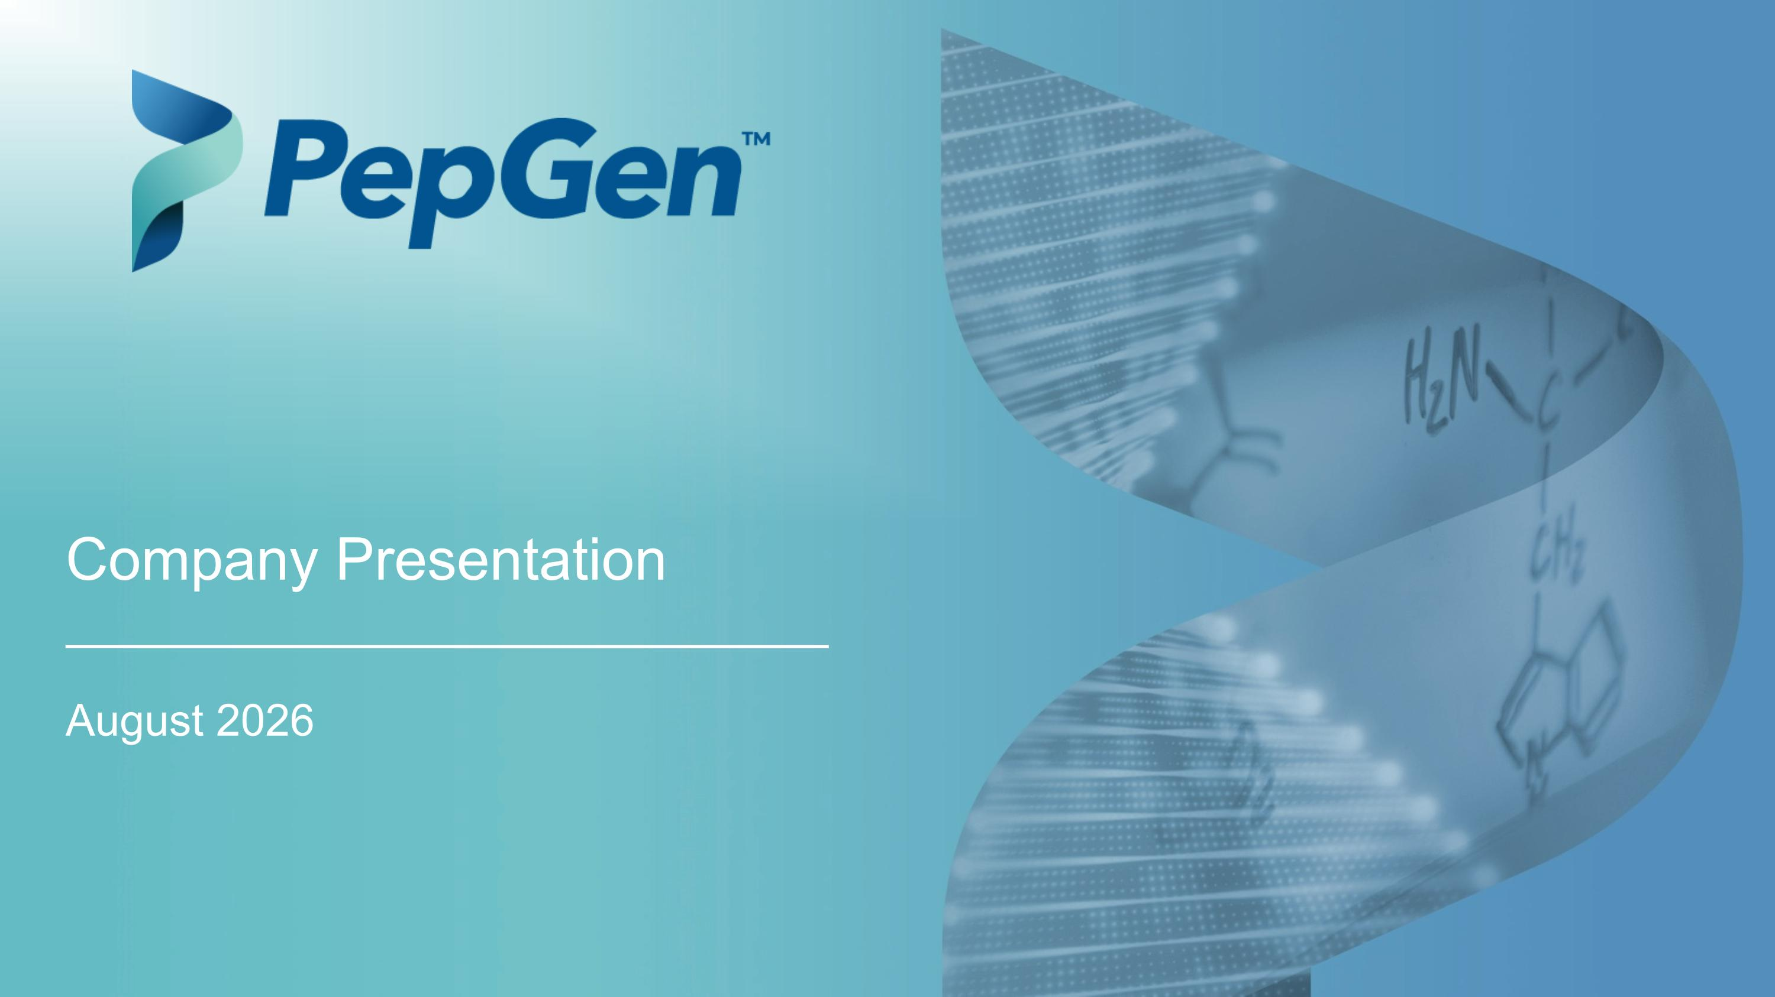
August 2026 Company Presentation

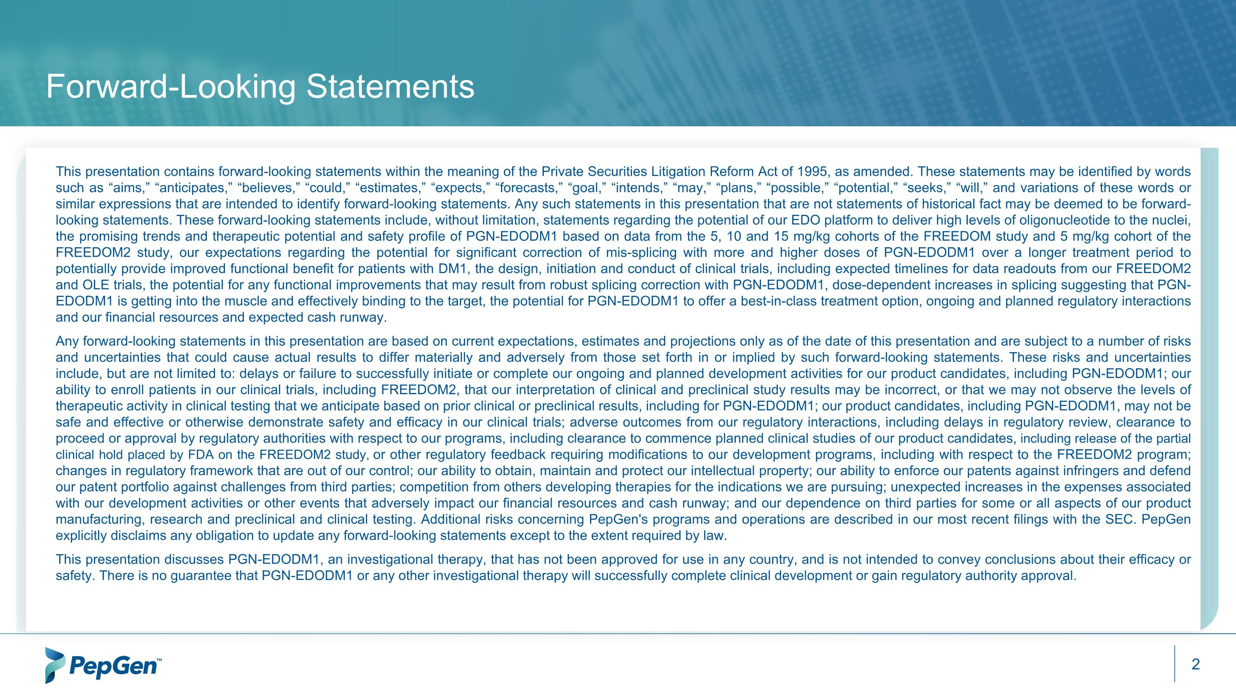
Forward-Looking Statements This presentation contains forward-looking statements within the meaning of the Private Securities Litigation Reform Act of 1995, as amended. These statements may be identified by words such as “aims,” “anticipates,” “believes,” “could,” “estimates,” “expects,” “forecasts,” “goal,” “intends,” “may,” “plans,” “possible,” “potential,” “seeks,” “will,” and variations of these words or similar expressions that are intended to identify forward-looking statements. Any such statements in this presentation that are not statements of historical fact may be deemed to be forward-looking statements. These forward-looking statements include, without limitation, statements regarding the potential of our EDO platform to deliver high levels of oligonucleotide to the nuclei, the promising trends and therapeutic potential and safety profile of PGN-EDODM1 based on data from the 5, 10 and 15 mg/kg cohorts of the FREEDOM study and 5 mg/kg cohort of the FREEDOM2 study, our expectations regarding the potential for significant correction of mis-splicing with more and higher doses of PGN-EDODM1 over a longer treatment period to potentially provide improved functional benefit for patients with DM1, the design, initiation and conduct of clinical trials, including expected timelines for data readouts from our FREEDOM2 and OLE trials, the potential for any functional improvements that may result from robust splicing correction with PGN-EDODM1, dose-dependent increases in splicing suggesting that PGN-EDODM1 is getting into the muscle and effectively binding to the target, the potential for PGN-EDODM1 to offer a best-in-class treatment option, ongoing and planned regulatory interactions and our financial resources and expected cash runway. Any forward-looking statements in this presentation are based on current expectations, estimates and projections only as of the date of this presentation and are subject to a number of risks and uncertainties that could cause actual results to differ materially and adversely from those set forth in or implied by such forward-looking statements. These risks and uncertainties include, but are not limited to: delays or failure to successfully initiate or complete our ongoing and planned development activities for our product candidates, including PGN-EDODM1; our ability to enroll patients in our clinical trials, including FREEDOM2, that our interpretation of clinical and preclinical study results may be incorrect, or that we may not observe the levels of therapeutic activity in clinical testing that we anticipate based on prior clinical or preclinical results, including for PGN-EDODM1; our product candidates, including PGN-EDODM1, may not be safe and effective or otherwise demonstrate safety and efficacy in our clinical trials; adverse outcomes from our regulatory interactions, including delays in regulatory review, clearance to proceed or approval by regulatory authorities with respect to our programs, including clearance to commence planned clinical studies of our product candidates, including release of the partial clinical hold placed by FDA on the FREEDOM2 study, or other regulatory feedback requiring modifications to our development programs, including with respect to the FREEDOM2 program; changes in regulatory framework that are out of our control; our ability to obtain, maintain and protect our intellectual property; our ability to enforce our patents against infringers and defend our patent portfolio against challenges from third parties; competition from others developing therapies for the indications we are pursuing; unexpected increases in the expenses associated with our development activities or other events that adversely impact our financial resources and cash runway; and our dependence on third parties for some or all aspects of our product manufacturing, research and preclinical and clinical testing. Additional risks concerning PepGen's programs and operations are described in our most recent filings with the SEC. PepGen explicitly disclaims any obligation to update any forward-looking statements except to the extent required by law. This presentation discusses PGN-EDODM1, an investigational therapy, that has not been approved for use in any country, and is not intended to convey conclusions about their efficacy or safety. There is no guarantee that PGN-EDODM1 or any other investigational therapy will successfully complete clinical development or gain regulatory authority approval.

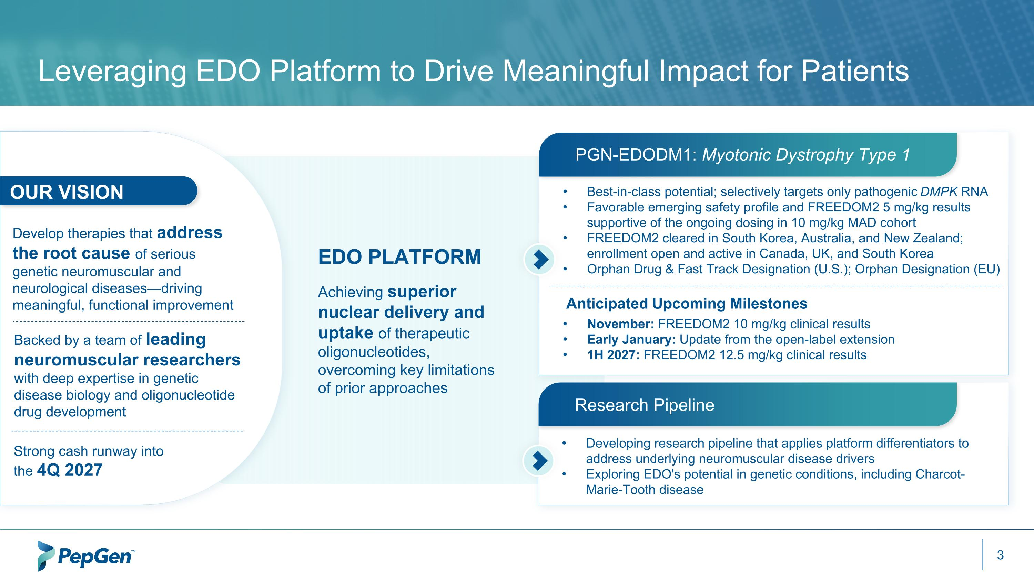
Leveraging EDO Platform to Drive Meaningful Impact for Patients PGN-EDODM1: Myotonic Dystrophy Type 1 Best-in-class potential; selectively targets only pathogenic DMPK RNA Favorable emerging safety profile and FREEDOM2 5 mg/kg results supportive of the ongoing dosing in 10 mg/kg MAD cohort FREEDOM2 cleared in South Korea, Australia, and New Zealand; enrollment open and active in Canada, UK, and South Korea Orphan Drug & Fast Track Designation (U.S.); Orphan Designation (EU) Developing research pipeline that applies platform differentiators to address underlying neuromuscular disease drivers Exploring EDO's potential in genetic conditions, including Charcot-Marie-Tooth disease Research Pipeline EDO PLATFORM Achieving superior nuclear delivery and uptake of therapeutic oligonucleotides, overcoming key limitations of prior approaches Backed by a team of leading neuromuscular researchers with deep expertise in genetic disease biology and oligonucleotide drug development Develop therapies that address the root cause of serious genetic neuromuscular and neurological diseases—driving meaningful, functional improvement November: FREEDOM2 10 mg/kg clinical results Early January: Update from the open-label extension 1H 2027: FREEDOM2 12.5 mg/kg clinical results Anticipated Upcoming Milestones Strong cash runway into the 4Q 2027 OUR VISION

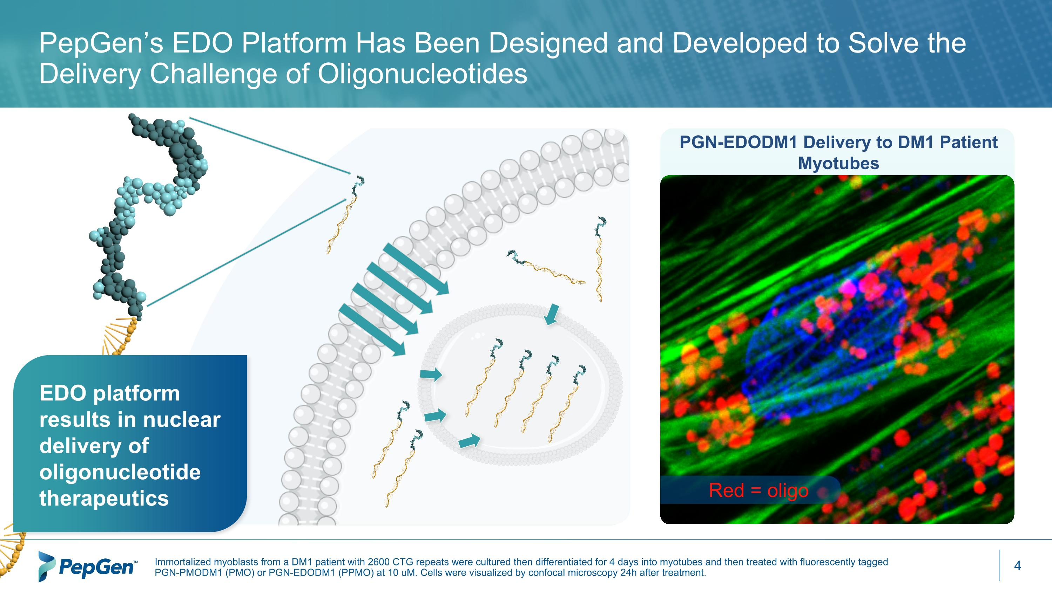
PGN-EDODM1 Delivery to DM1 Patient Myotubes Red = oligo PepGen’s EDO Platform Has Been Designed and Developed to Solve the Delivery Challenge of Oligonucleotides Immortalized myoblasts from a DM1 patient with 2600 CTG repeats were cultured then differentiated for 4 days into myotubes and then treated with fluorescently tagged PGN-PMODM1 (PMO) or PGN-EDODM1 (PPMO) at 10 uM. Cells were visualized by confocal microscopy 24h after treatment. EDO platform results in nuclear delivery of oligonucleotide therapeutics

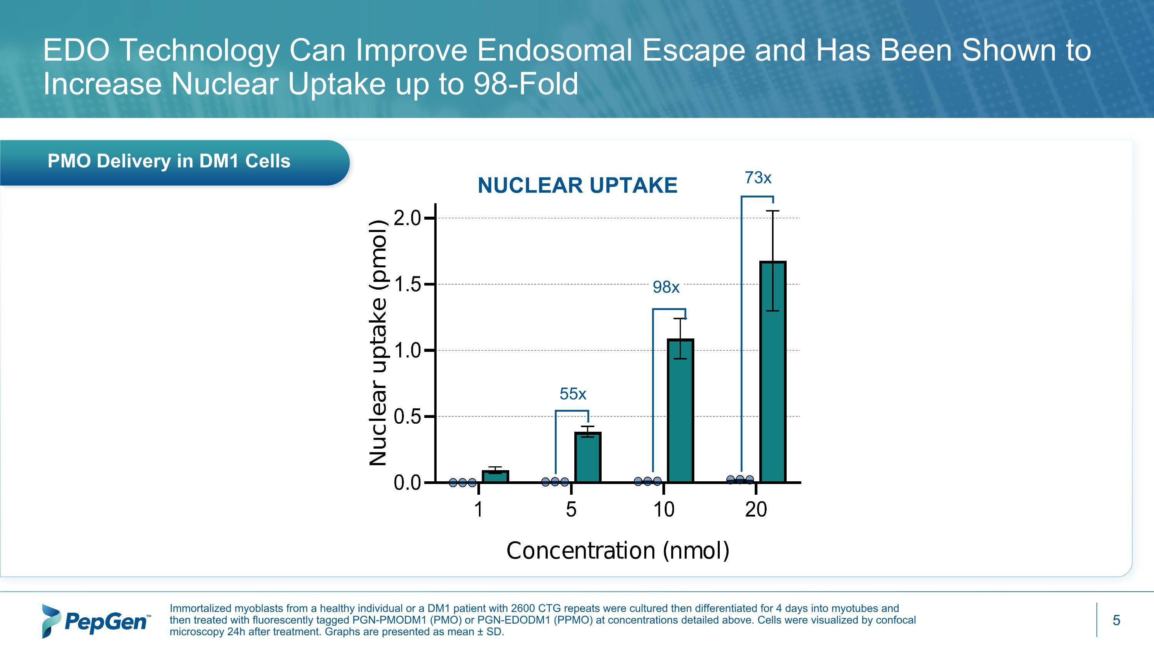
55x 98x 73x PMO Delivery in DM1 Cells EDO Technology Can Improve Endosomal Escape and Has Been Shown to Increase Nuclear Uptake up to 98-Fold NUCLEAR UPTAKE Immortalized myoblasts from a healthy individual or a DM1 patient with 2600 CTG repeats were cultured then differentiated for 4 days into myotubes and then treated with fluorescently tagged PGN-PMODM1 (PMO) or PGN-EDODM1 (PPMO) at concentrations detailed above. Cells were visualized by confocal microscopy 24h after treatment. Graphs are presented as mean ± SD.

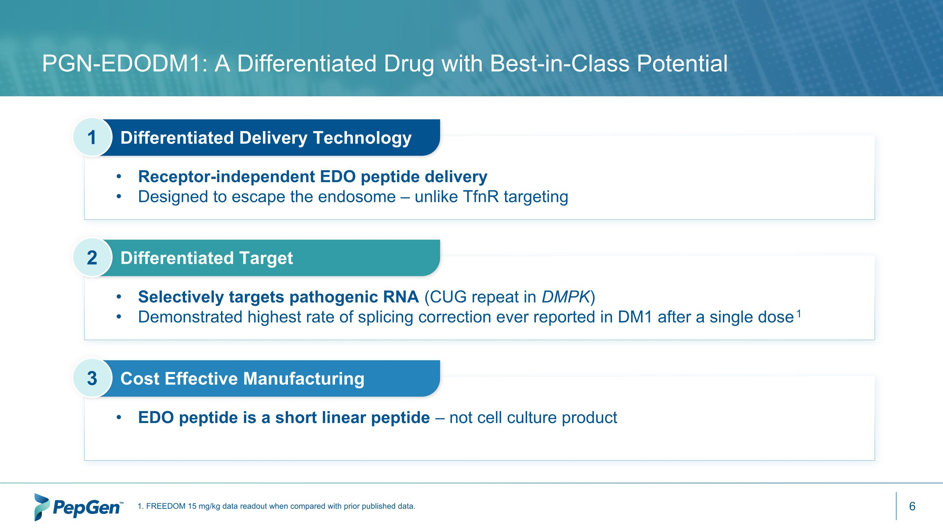
1. FREEDOM 15 mg/kg data readout when compared with prior published data. Differentiated Delivery Technology Receptor-independent EDO peptide delivery Designed to escape the endosome – unlike TfnR targeting 1 Differentiated Target Selectively targets pathogenic RNA (CUG repeat in DMPK) Demonstrated highest rate of splicing correction ever reported in DM1 after a single dose1 2 Cost Effective Manufacturing EDO peptide is a short linear peptide – not cell culture product 3 PGN-EDODM1: A Differentiated Drug with Best-in-Class Potential


PGN-EDODM1 – ?Myotonic Dystrophy Type 1 (DM1)

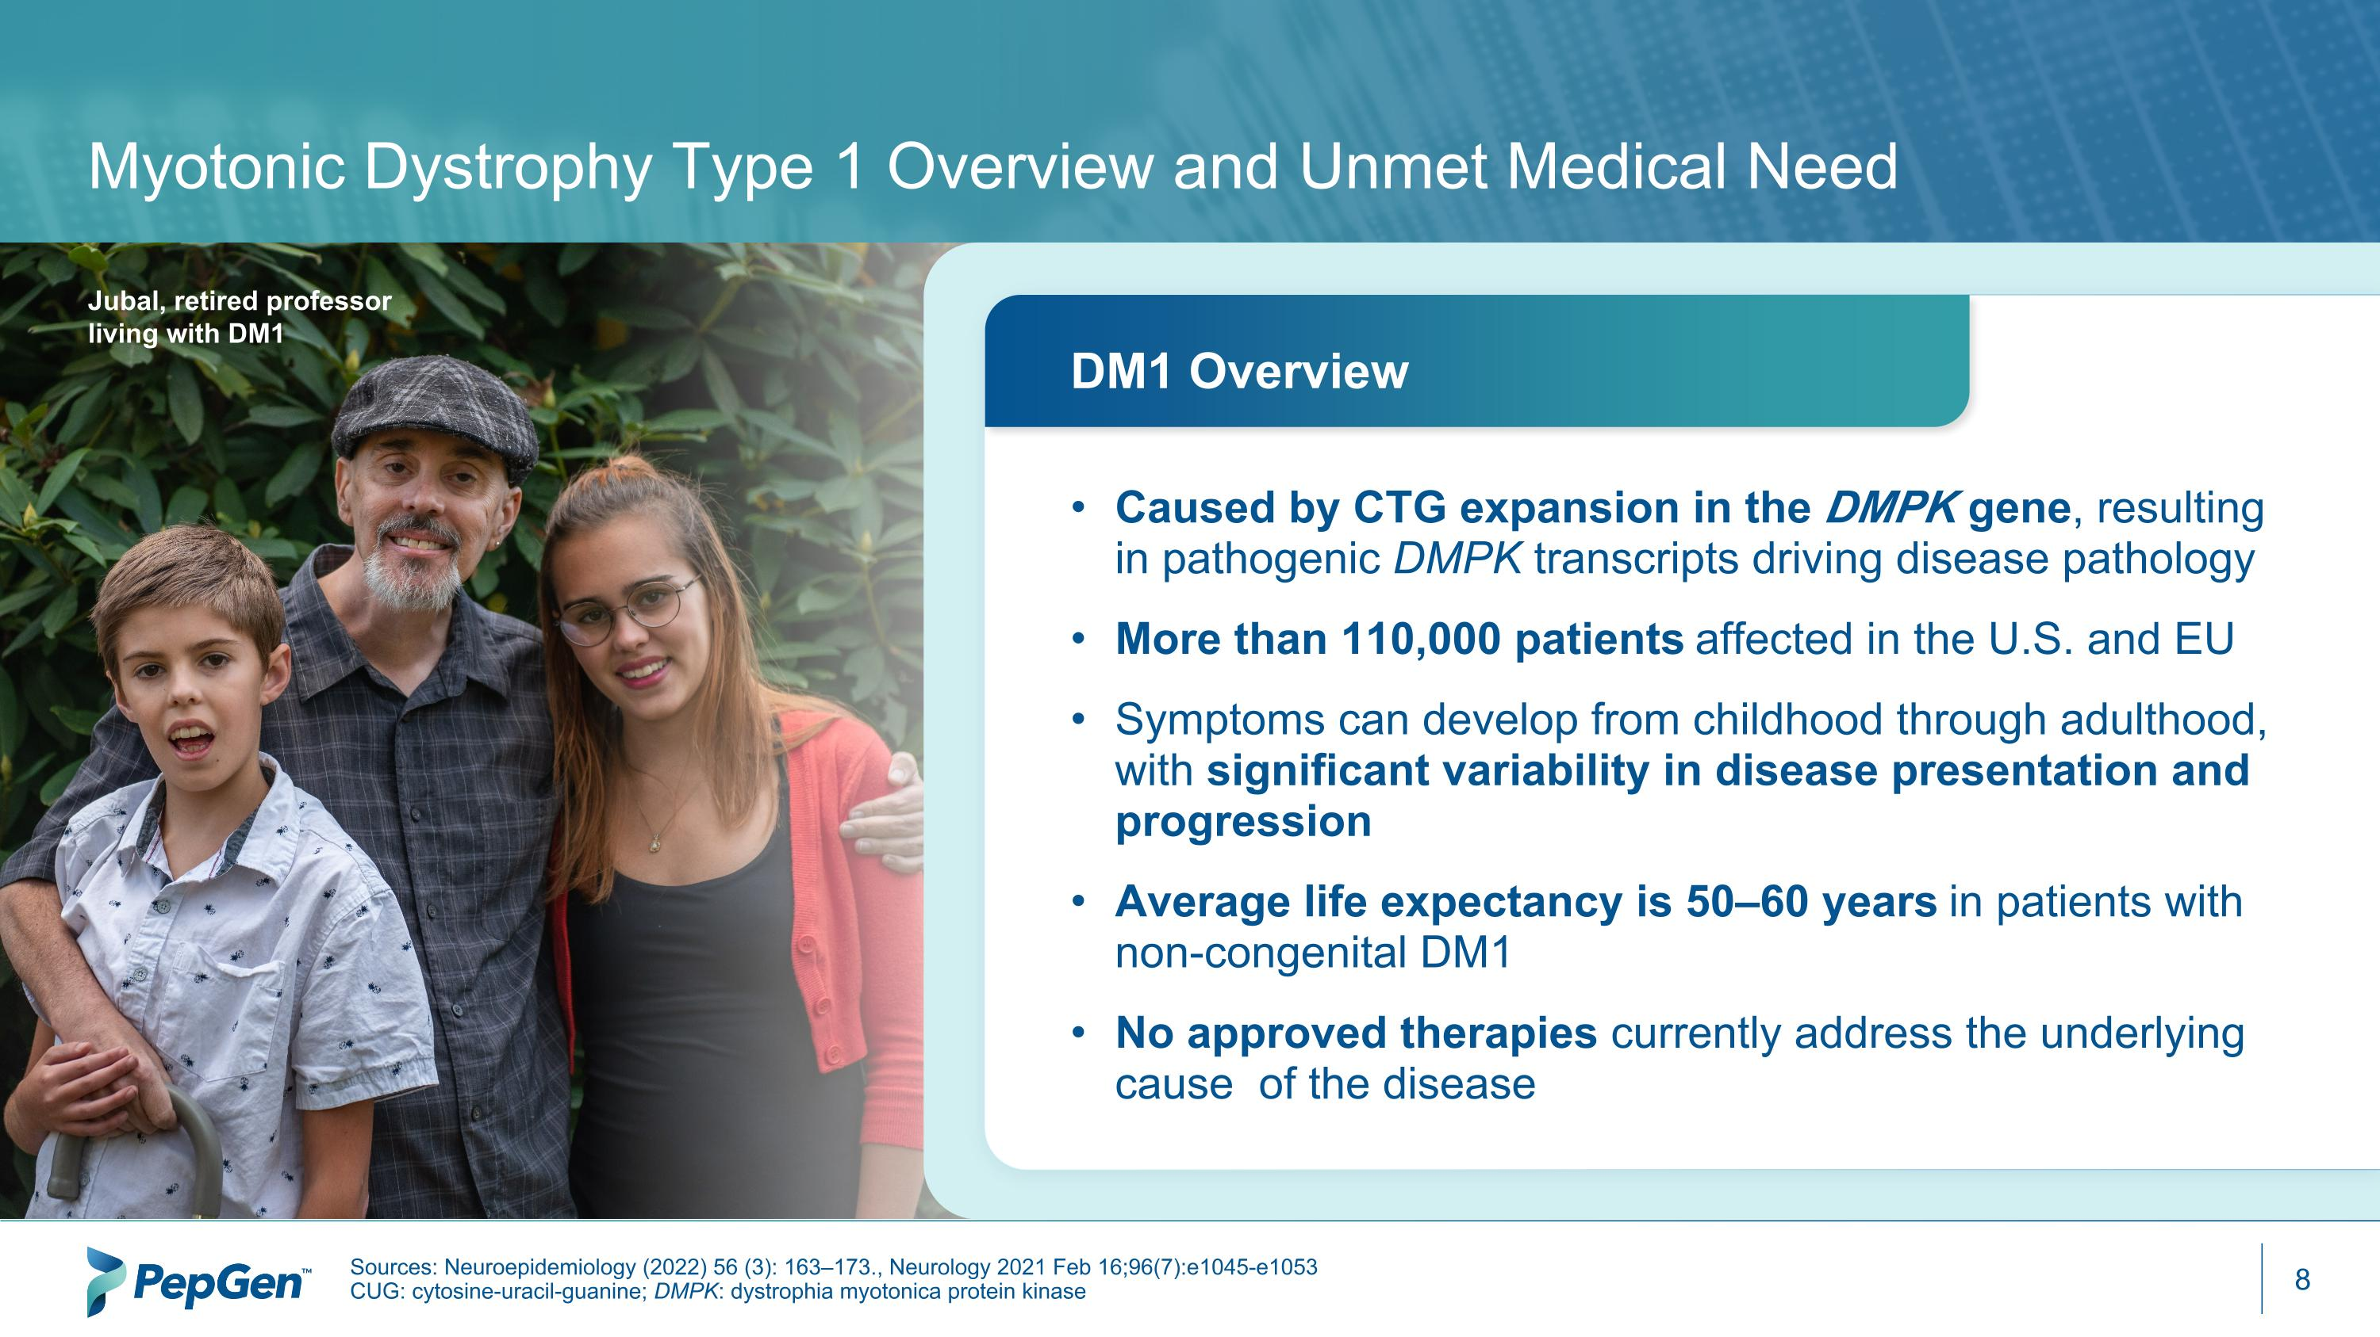
Myotonic Dystrophy Type 1 Overview and Unmet Medical Need Sources: Neuroepidemiology (2022) 56 (3): 163–173., Neurology 2021 Feb 16;96(7):e1045-e1053 CUG: cytosine-uracil-guanine; DMPK: dystrophia myotonica protein kinase Jubal, retired professor ?living with DM1 Caused by CTG expansion in the DMPK gene, resulting in pathogenic DMPK transcripts driving disease pathology More than 110,000 patients affected in the U.S. and EU Symptoms can develop from childhood through adulthood, with significant variability in disease presentation and progression Average life expectancy is 50–60 years in patients with non-congenital DM1 No approved therapies currently address the underlying cause of the disease DM1 Overview

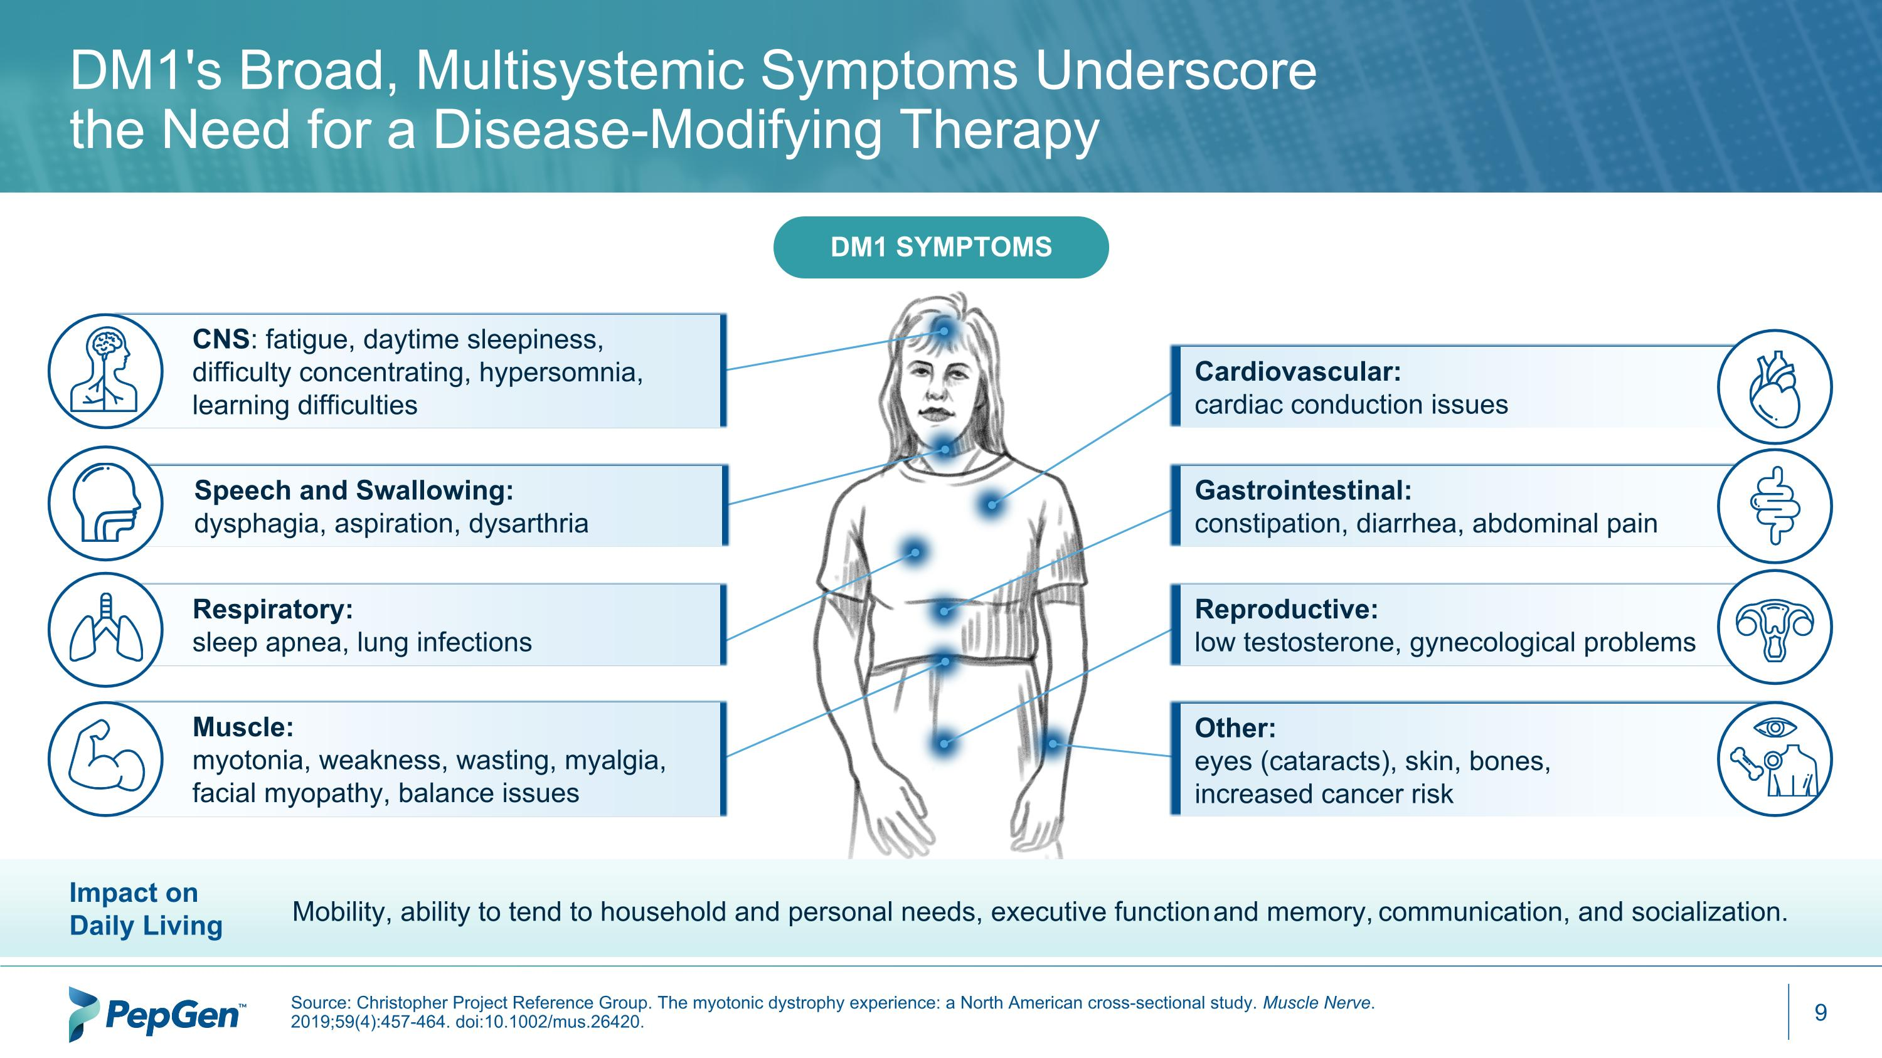
Cardiovascular: ?cardiac conduction issues Reproductive: ?low testosterone, gynecological problems CNS: fatigue, daytime sleepiness, ?difficulty concentrating, hypersomnia, learning difficulties Muscle: ?myotonia, weakness, wasting, myalgia, facial myopathy, balance issues Respiratory: ?sleep apnea, lung infections Speech and Swallowing: ?dysphagia, aspiration, dysarthria Gastrointestinal: ?constipation, diarrhea, abdominal pain Other: eyes (cataracts), skin, bones, increased cancer risk Source: Christopher Project Reference Group. The myotonic dystrophy experience: a North American cross-sectional study. Muscle Nerve. 2019;59(4):457-464. doi:10.1002/mus.26420. DM1's Broad, Multisystemic Symptoms Underscore the Need for a Disease-Modifying Therapy DM1 Symptoms Impact on Daily Living Mobility, ability to tend to household and personal needs, executive function and memory, communication, and socialization.

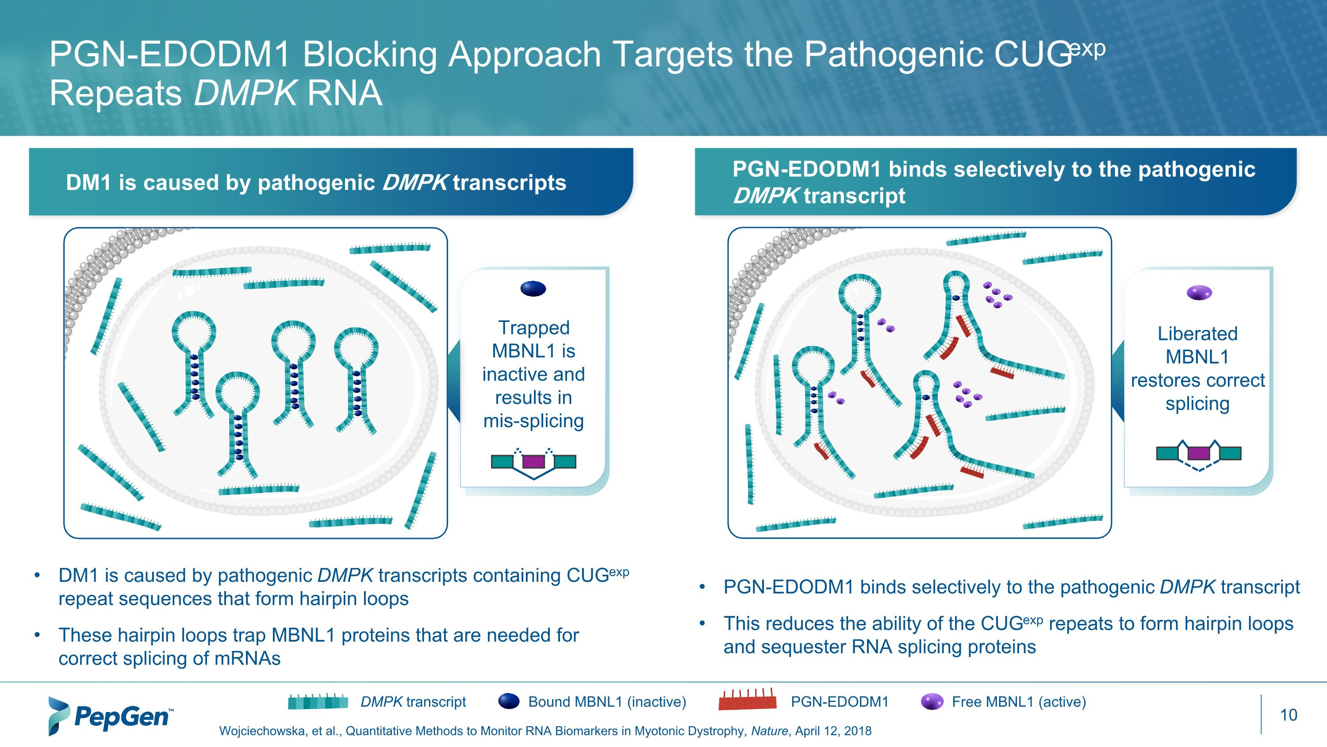
PGN-EDODM1 Blocking Approach Targets the Pathogenic CUGexp Repeats DMPK RNA Wojciechowska, et al., Quantitative Methods to Monitor RNA Biomarkers in Myotonic Dystrophy, Nature, April 12, 2018 DM1 is caused by pathogenic DMPK transcripts PGN-EDODM1 binds selectively to the pathogenic DMPK transcript Bound MBNL1 (inactive) DMPK transcript Free MBNL1 (active) PGN-EDODM1 PGN-EDODM1 binds selectively to the pathogenic DMPK transcript This reduces the ability of the CUGexp repeats to form hairpin loops and sequester RNA splicing proteins DM1 is caused by pathogenic DMPK transcripts containing CUGexp repeat sequences that form hairpin loops These hairpin loops trap MBNL1 proteins that are needed for correct splicing of mRNAs Trapped MBNL1 is inactive and results in mis-splicing Liberated MBNL1 restores correct splicing

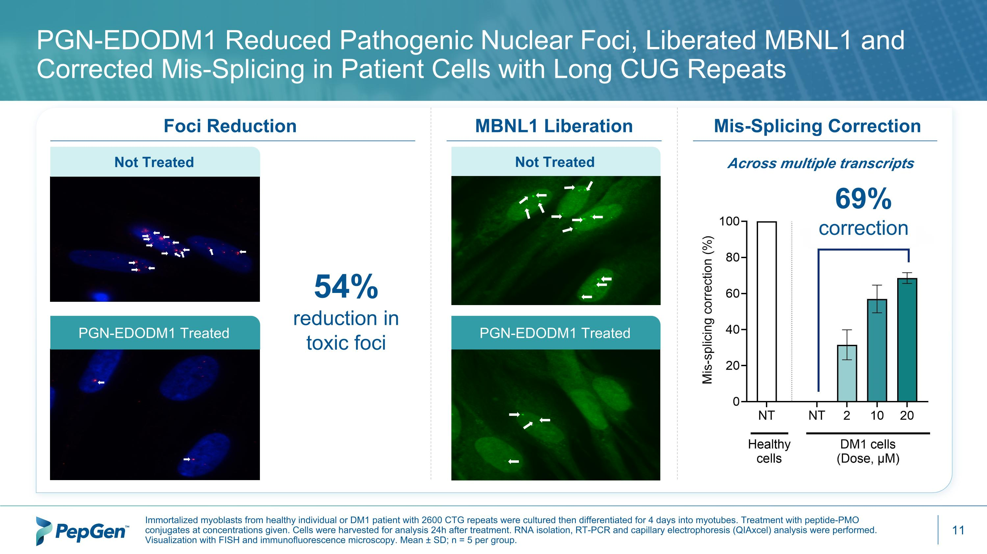
MBNL1 Liberation Foci Reduction PGN-EDODM1 Reduced Pathogenic Nuclear Foci, Liberated MBNL1 and Corrected Mis-Splicing in Patient Cells with Long CUG Repeats Immortalized myoblasts from healthy individual or DM1 patient with 2600 CTG repeats were cultured then differentiated for 4 days into myotubes. Treatment with peptide-PMO conjugates at concentrations given. Cells were harvested for analysis 24h after treatment. RNA isolation, RT-PCR and capillary electrophoresis (QIAxcel) analysis were performed. Visualization with FISH and immunofluorescence microscopy. Mean ± SD; n = 5 per group. Not Treated PGN-EDODM1 Treated Not Treated PGN-EDODM1 Treated 54% reduction in toxic foci Across multiple transcripts Mis-Splicing Correction 69%?correction

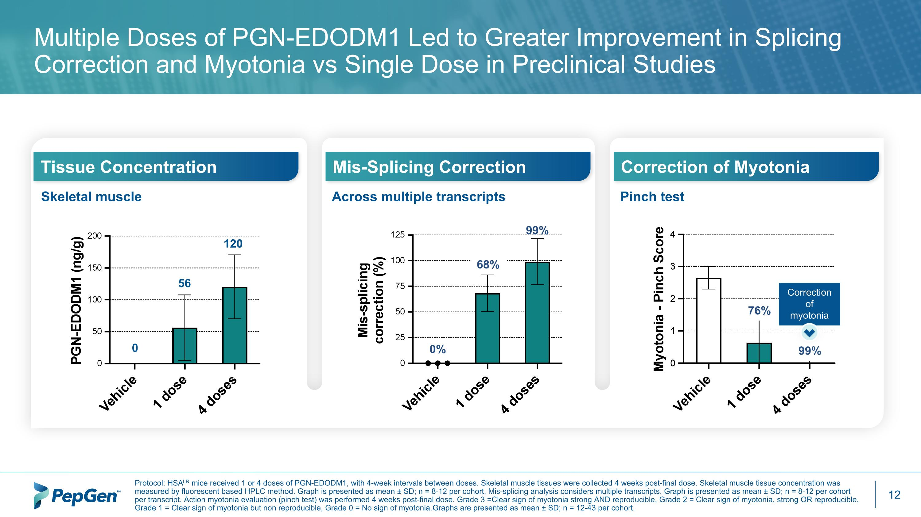
Multiple Doses of PGN-EDODM1 Led to Greater Improvement in Splicing Correction and Myotonia vs Single Dose in Preclinical Studies Protocol: HSALR mice received 1 or 4 doses of PGN-EDODM1, with 4-week intervals between doses. Skeletal muscle tissues were collected 4 weeks post-final dose. Skeletal muscle tissue concentration was measured by fluorescent based HPLC method. Graph is presented as mean ± SD; n = 8-12 per cohort. Mis-splicing analysis considers multiple transcripts. Graph is presented as mean ± SD; n = 8-12 per cohort per transcript. Action myotonia evaluation (pinch test) was performed 4 weeks post-final dose. Grade 3 = Clear sign of myotonia strong AND reproducible, Grade 2 = Clear sign of myotonia, strong OR reproducible, Grade 1 = Clear sign of myotonia but non reproducible, Grade 0 = No sign of myotonia. Graphs are presented as mean ± SD; n = 12-43 per cohort. Skeletal muscle Tissue Concentration Across multiple transcripts Mis-Splicing Correction Correction of Myotonia Pinch test 56 120 0 68% 99% 0% 76% 99% Correction of myotonia


PGN-EDODM1 – ?FREEDOM SAD Trial in DM1

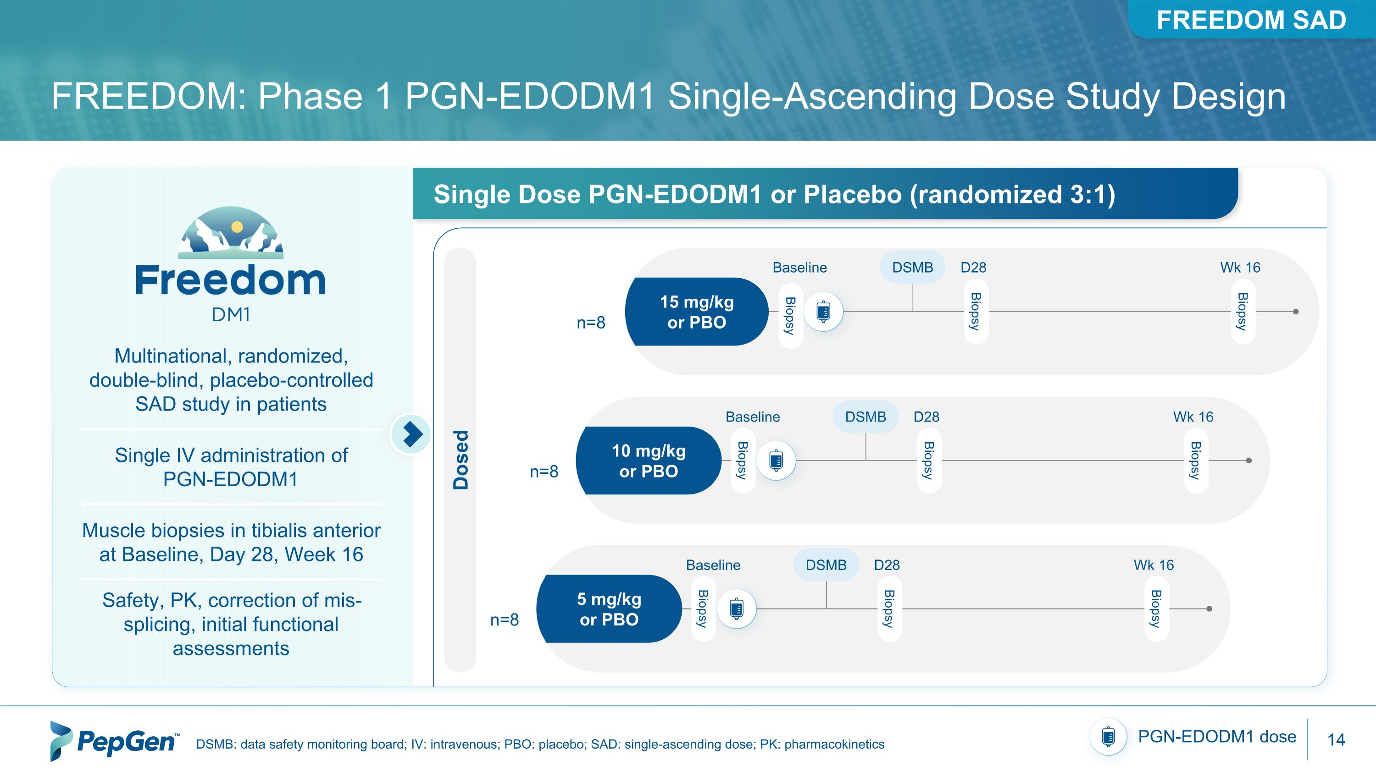
FREEDOM: Phase 1 PGN-EDODM1 Single-Ascending Dose Study Design DSMB: data safety monitoring board; IV: intravenous; PBO: placebo; SAD: single-ascending dose; PK: pharmacokinetics PGN-EDODM1 dose Multinational, randomized,?double-blind, placebo-controlled SAD study in patients Single IV administration of?PGN-EDODM1 Muscle biopsies in tibialis anterior?at Baseline, Day 28, Week 16 Safety, PK, correction of mis-splicing, initial functional assessments Single Dose PGN-EDODM1 or Placebo (randomized 3:1) 15 mg/kg?or PBO Baseline DSMB Wk 16 D28 Biopsy Biopsy Biopsy 10 mg/kg?or PBO Baseline DSMB Wk 16 D28 Biopsy Biopsy Biopsy Dosed n=8 n=8 5 mg/kg?or PBO Baseline DSMB Wk 16 D28 Biopsy Biopsy Biopsy n=8 FREEDOM SAD

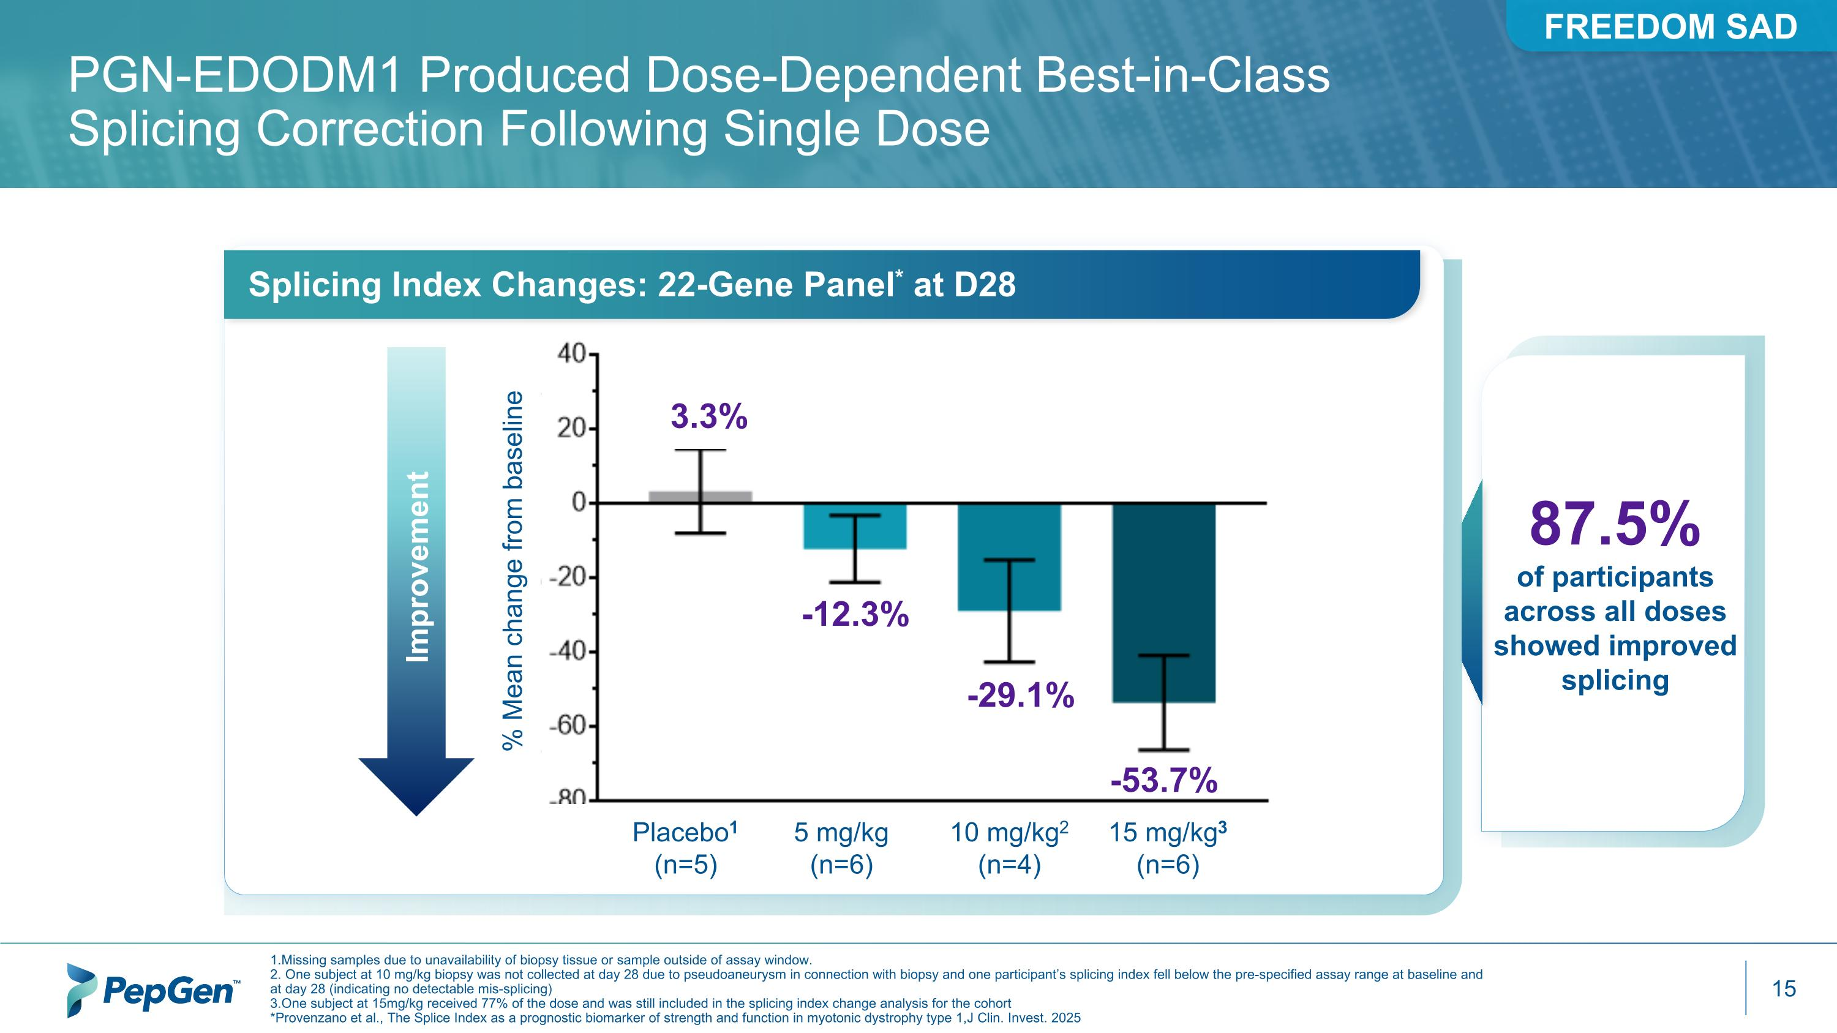
PGN-EDODM1 Produced Dose-Dependent Best-in-Class Splicing Correction Following Single Dose Splicing Index Changes: 22-Gene Panel* at D28 Improvement -53.7% -29.1% 3.3% -12.3% 87.5% of participants across all doses showed improved splicing % Mean change from baseline Placebo1 (n=5) 5 mg/kg (n=6) 10 mg/kg2 (n=4) 15 mg/kg3 (n=6) 1.Missing samples due to unavailability of biopsy tissue or sample outside of assay window. 2. One subject at 10 mg/kg biopsy was not collected at day 28 due to pseudoaneurysm in connection with biopsy and one participant’s splicing index fell below the pre-specified assay range at baseline and at day 28 (indicating no detectable mis-splicing) 3.One subject at 15mg/kg received 77% of the dose and was still included in the splicing index change analysis for the cohort *Provenzano et al., The Splice Index as a prognostic biomarker of strength and function in myotonic dystrophy type 1,J Clin. Invest. 2025 FREEDOM SAD

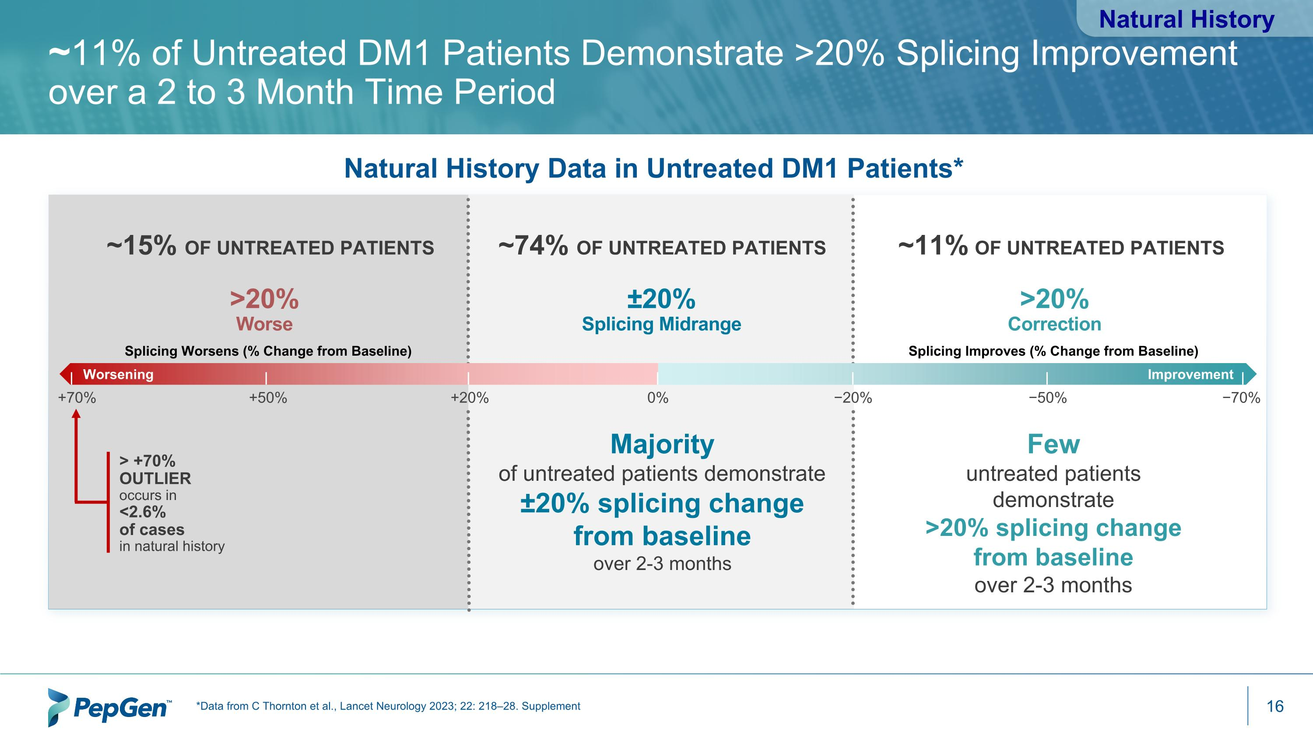
Natural History Data in Untreated DM1 Patients* +70% +50% >20% ?Worse Splicing Worsens (% Change from Baseline) ~15% of untreated patients > +70% ?OUTLIER occurs in <2.6% of cases in natural history +20% 0% −20% −50% −70% Splicing Improves (% Change from Baseline) ~74% of untreated patients ~11% of untreated patients Worsening Improvement ±20% ?Splicing Midrange >20% ?Correction Majority of untreated patients demonstrate ±20% splicing change ?from baseline ?over 2-3 months Few untreated patients demonstrate >20% splicing change from baseline ?over 2-3 months *Data from C Thornton et al., Lancet Neurology 2023; 22: 218–28. Supplement ~11% of Untreated DM1 Patients Demonstrate >20% Splicing Improvement over a 2 to 3 Month Time Period Natural History

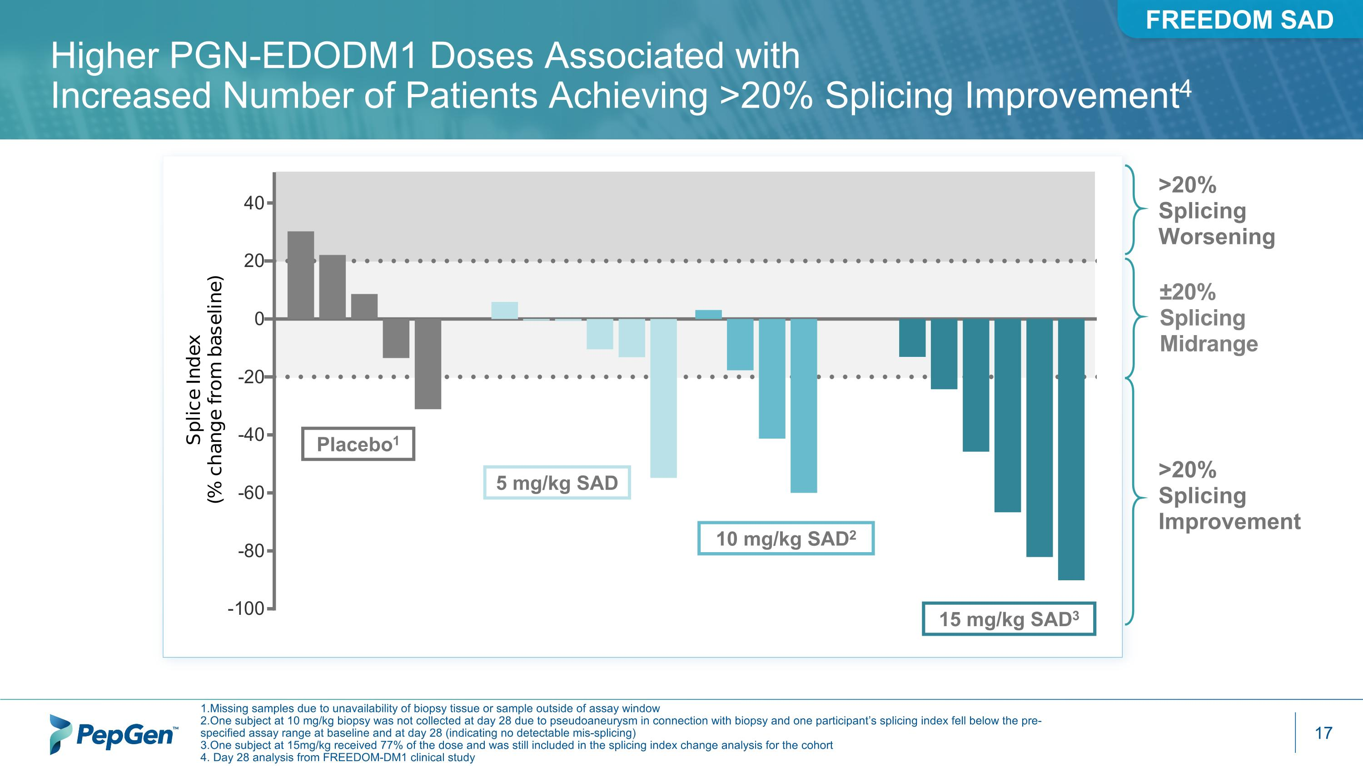
1.Missing samples due to unavailability of biopsy tissue or sample outside of assay window 2.One subject at 10 mg/kg biopsy was not collected at day 28 due to pseudoaneurysm in connection with biopsy and one participant’s splicing index fell below the pre-specified assay range at baseline and at day 28 (indicating no detectable mis-splicing) 3.One subject at 15mg/kg received 77% of the dose and was still included in the splicing index change analysis for the cohort 4. Day 28 analysis from FREEDOM-DM1 clinical study Higher PGN-EDODM1 Doses Associated with Increased Number of Patients Achieving >20% Splicing Improvement4 Placebo1 5 mg/kg SAD 10 mg/kg SAD2 ±20% ?Splicing Midrange >20% Splicing Improvement 15 mg/kg SAD3 >20% Splicing Worsening FREEDOM SAD

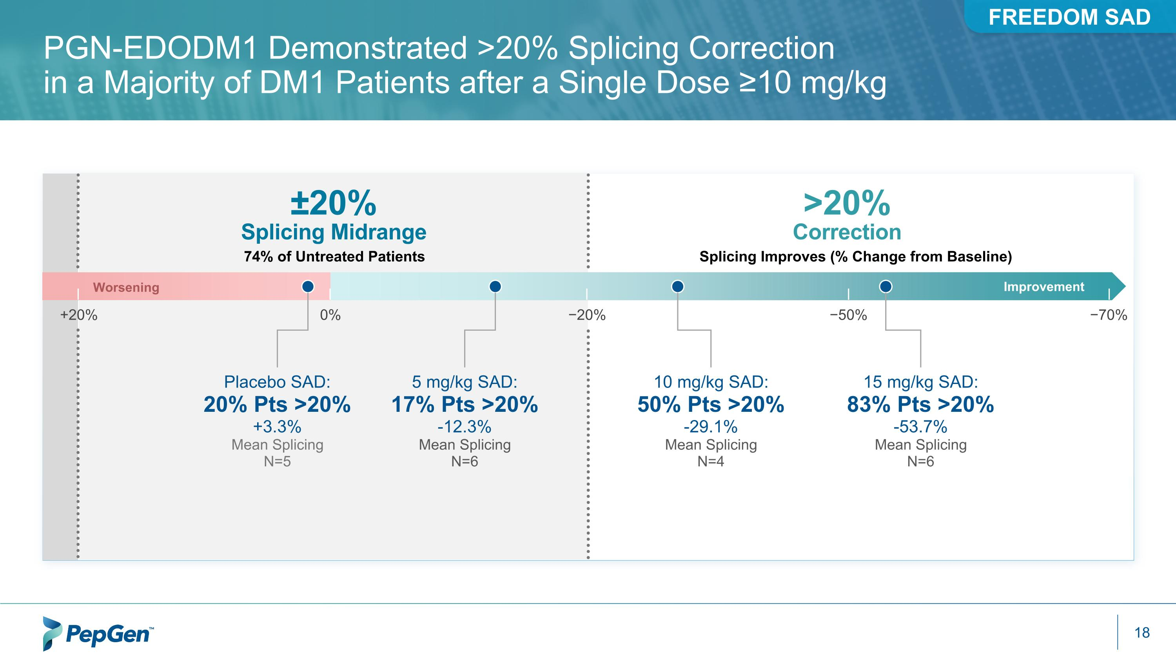
PGN-EDODM1 Demonstrated >20% Splicing Correction ?in a Majority of DM1 Patients after a Single Dose ≥10 mg/kg Splicing Improves (% Change from Baseline) >20% ?Correction ±20% ?Splicing Midrange 74% of Untreated Patients +20% 0% −20% −50% −70% Worsening Improvement Placebo SAD: 20% Pts >20% +3.3% Mean Splicing N=5 5 mg/kg SAD: 17% Pts >20% -12.3% Mean Splicing N=6 10 mg/kg SAD: 50% Pts >20% -29.1% Mean Splicing N=4 15 mg/kg SAD: 83% Pts >20% -53.7% Mean Splicing N=6 FREEDOM SAD

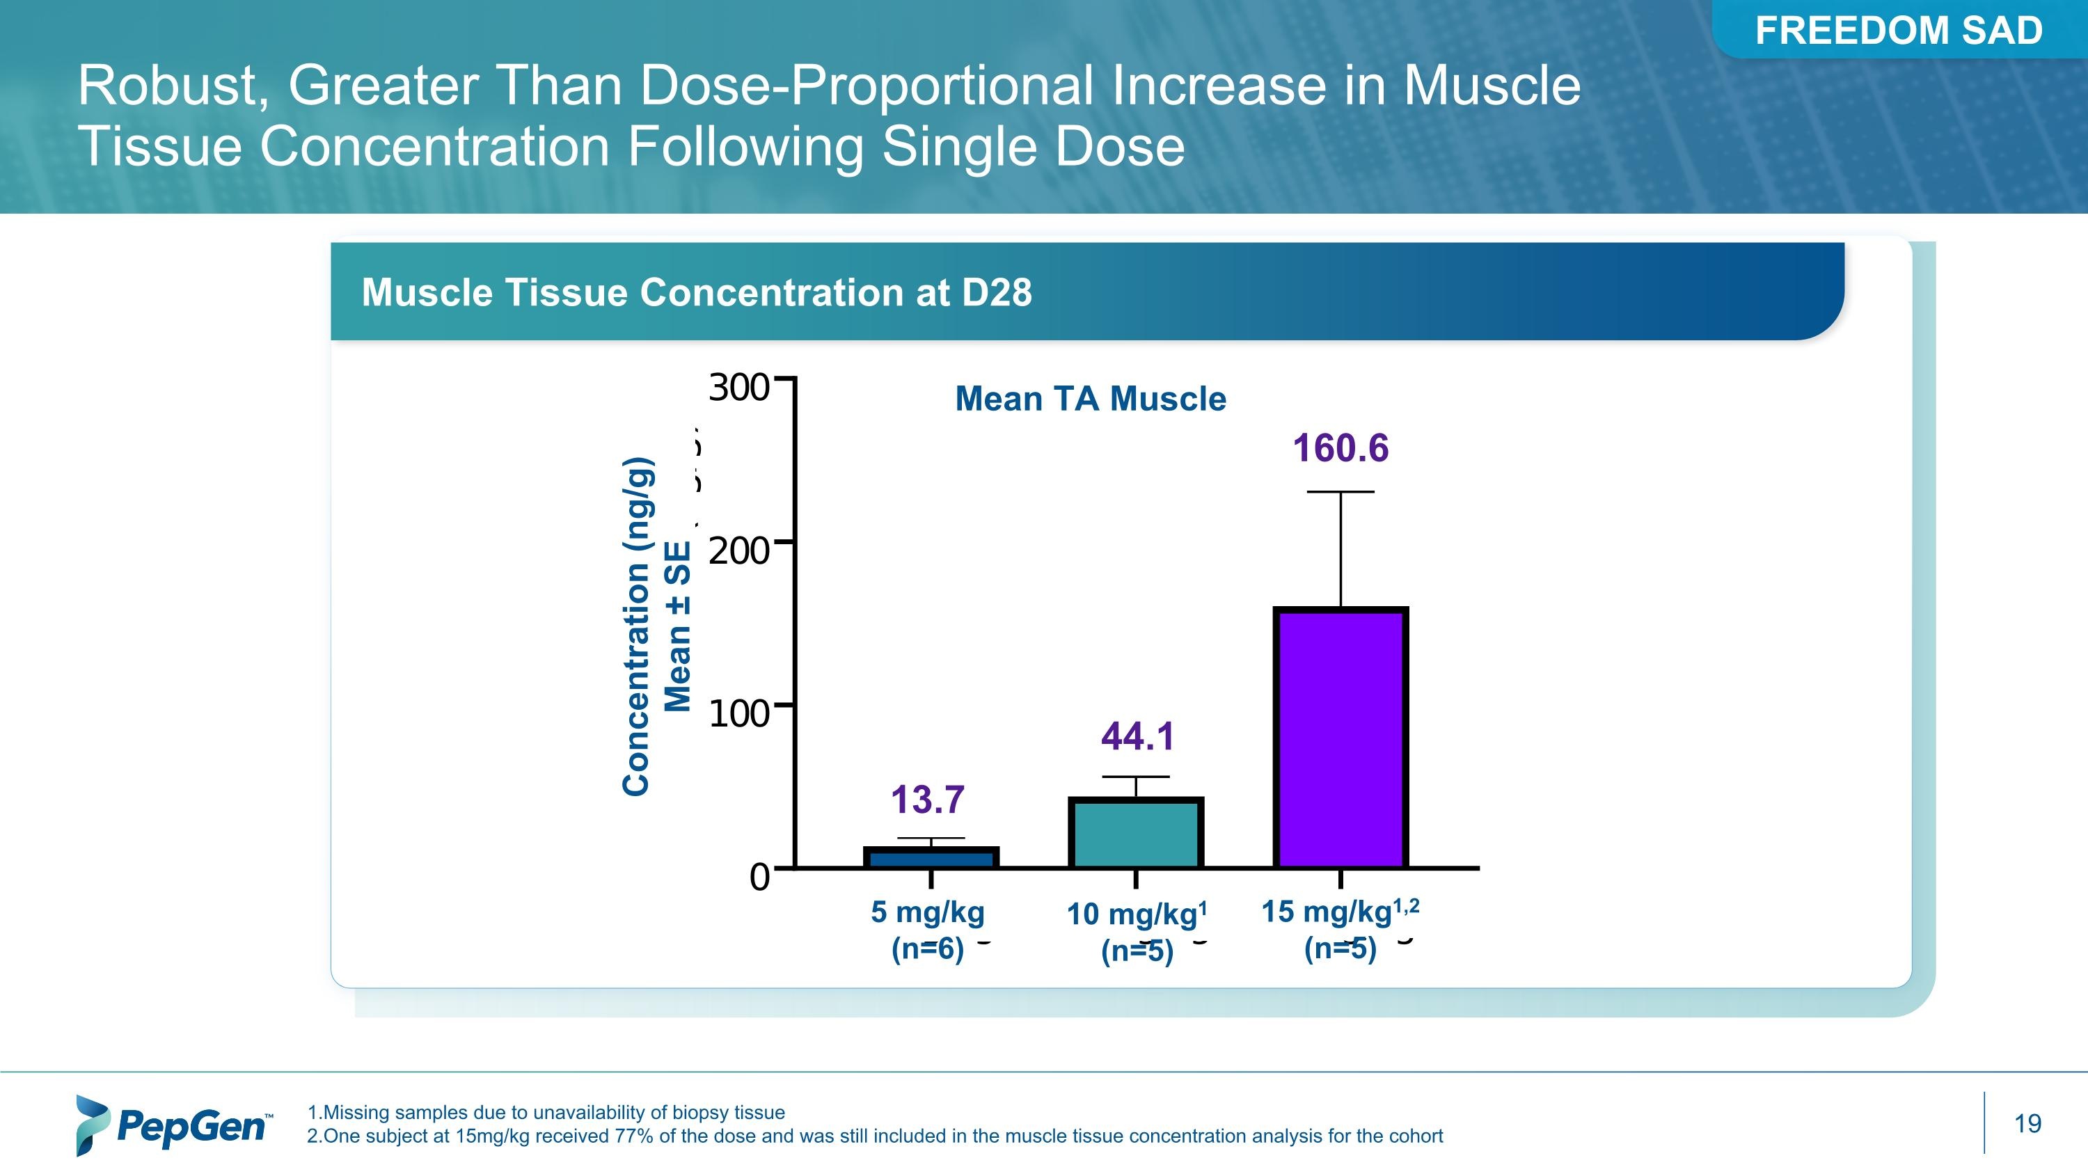
1.Missing samples due to unavailability of biopsy tissue 2.One subject at 15mg/kg received 77% of the dose and was still included in the muscle tissue concentration analysis for the cohort * Robust, Greater Than Dose-Proportional Increase in Muscle Tissue Concentration Following Single Dose 5 mg/kg (n=6) 10 mg/kg1 (n=5) 15 mg/kg1,2 (n=5) Concentration (ng/g) Mean ± SE 160.6 44.1 13.7 Muscle Tissue Concentration at D28 Mean TA Muscle FREEDOM SAD

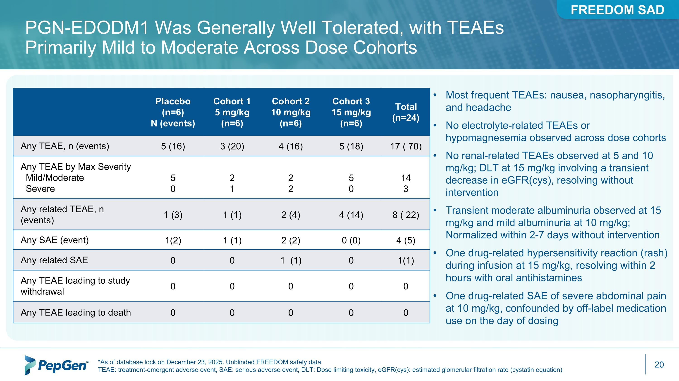
PGN-EDODM1 Was Generally Well Tolerated, with TEAEs Primarily Mild to Moderate Across Dose Cohorts *As of database lock on December 23, 2025. Unblinded FREEDOM safety data TEAE: treatment-emergent adverse event, SAE: serious adverse event, DLT: Dose limiting toxicity, eGFR(cys): estimated glomerular filtration rate (cystatin equation) Placebo (n=6) N (events) Cohort 1 5 mg/kg (n=6) Cohort 2 10 mg/kg (n=6) Cohort 3 15 mg/kg (n=6) Total (n=24) Any TEAE, n (events) 5 (16) 3 (20) 4 (16) 5 (18) 17 ( 70) Any TEAE by Max Severity Mild/Moderate Severe 5 0 2 1 2 2 5 0 14 3 Any related TEAE, n (events) 1 (3) 1 (1) 2 (4) 4 (14) 8 ( 22) Any SAE (event) 1(2) 1 (1) 2 (2) 0 (0) 4 (5) Any related SAE 0 0 1 (1) 0 1(1) Any TEAE leading to study withdrawal 0 0 0 0 0 Any TEAE leading to death 0 0 0 0 0 Most frequent TEAEs: nausea, nasopharyngitis, and headache No electrolyte-related TEAEs or hypomagnesemia observed across dose cohorts No renal-related TEAEs observed at 5 and 10 mg/kg; DLT at 15 mg/kg involving a transient decrease in eGFR(cys), resolving without intervention Transient moderate albuminuria observed at 15 mg/kg and mild albuminuria at 10 mg/kg; Normalized within 2-7 days without intervention One drug-related hypersensitivity reaction (rash) during infusion at 15 mg/kg, resolving within 2 hours with oral antihistamines One drug-related SAE of severe abdominal pain at 10 mg/kg, confounded by off-label medication use on the day of dosing FREEDOM SAD


PGN-EDODM1 – ?FREEDOM2 MAD Trial in DM1

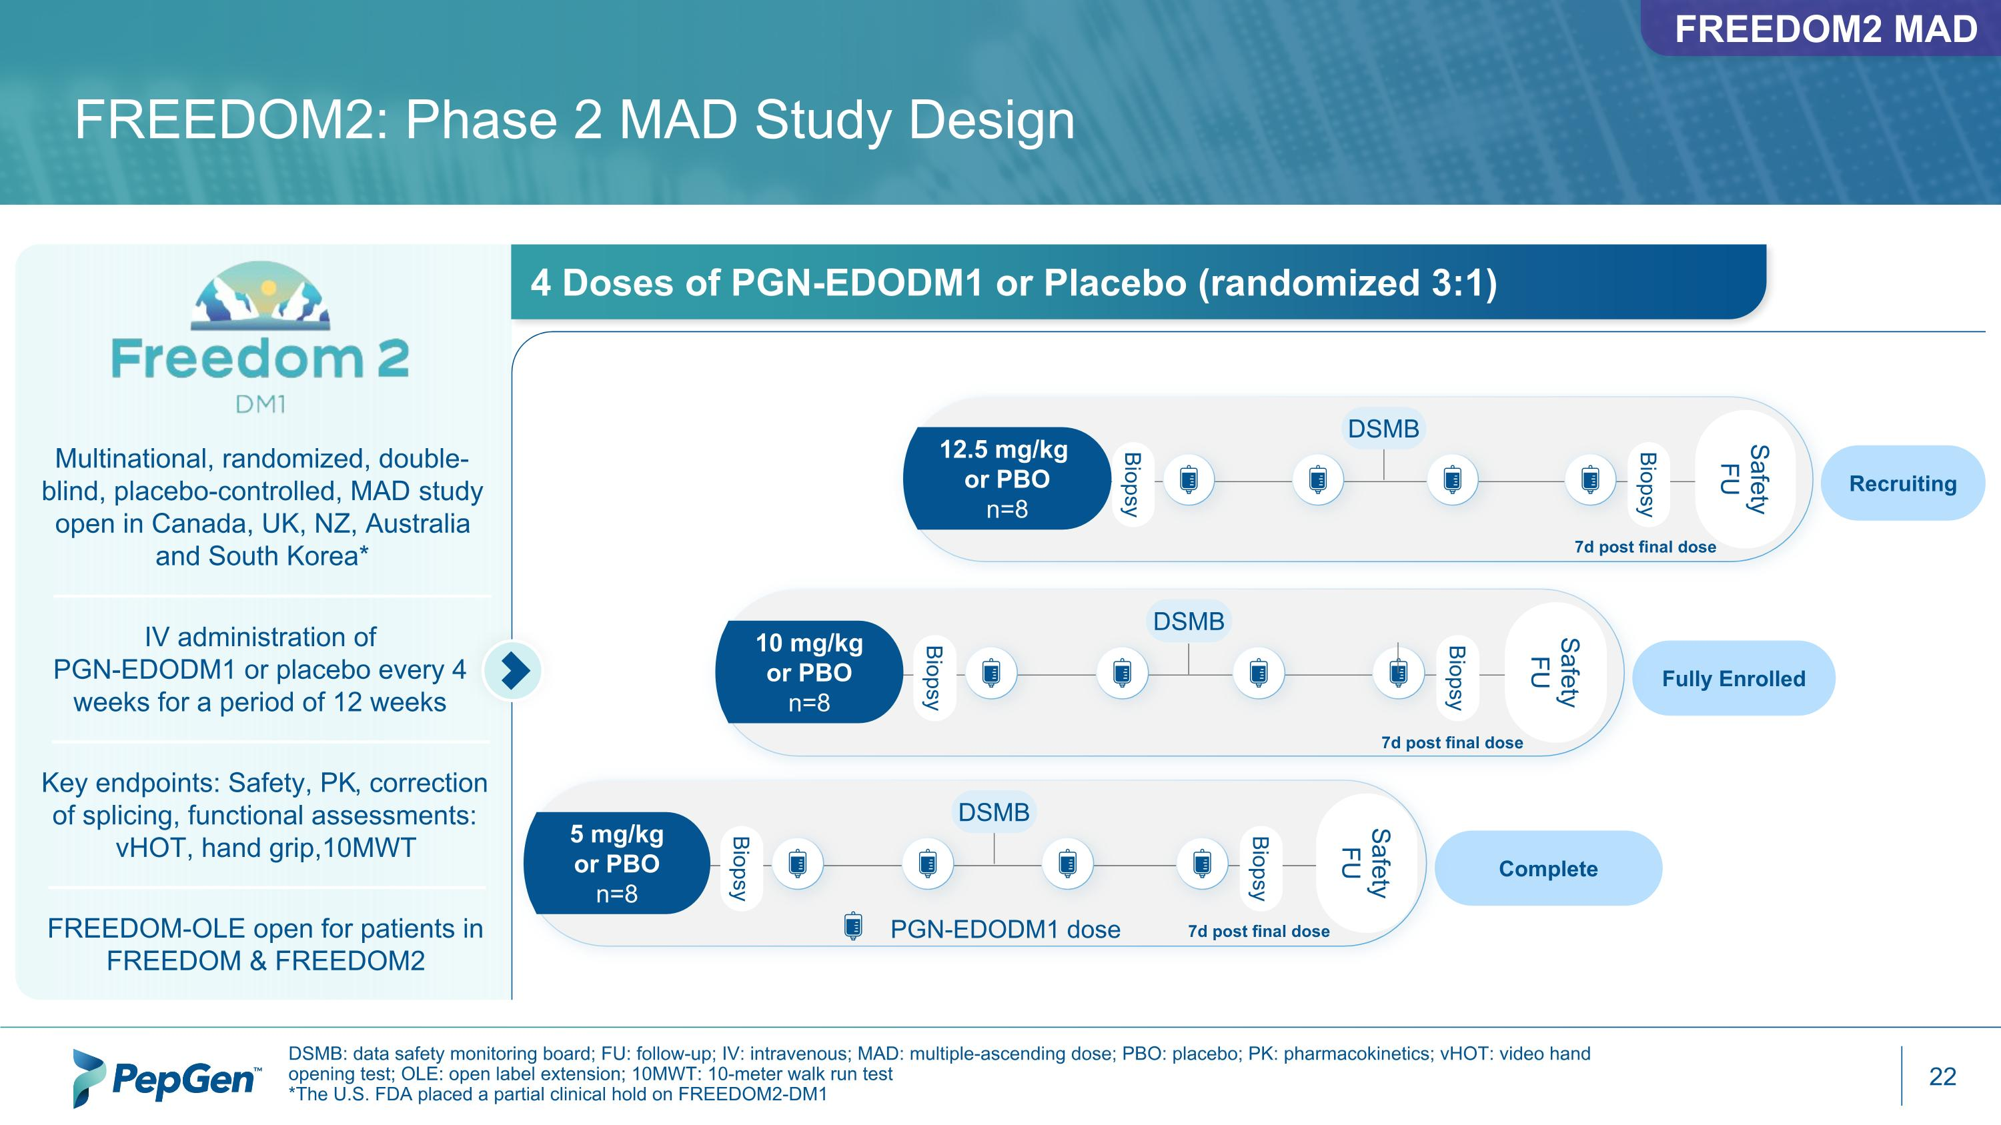
FREEDOM2: Phase 2 MAD Study Design DSMB: data safety monitoring board; FU: follow-up; IV: intravenous; MAD: multiple-ascending dose; PBO: placebo; PK: pharmacokinetics; vHOT: video hand opening test; OLE: open label extension; 10MWT: 10-meter walk run test *The U.S. FDA placed a partial clinical hold on FREEDOM2-DM1 Multinational, randomized, double-blind, placebo-controlled, MAD study open in Canada, UK, NZ, Australia and South Korea* IV administration of ?PGN-EDODM1 or placebo every 4 weeks for a period of 12 weeks FREEDOM-OLE open for patients in FREEDOM & FREEDOM2 Complete Key endpoints: Safety, PK, correction of splicing, functional assessments: vHOT, hand grip,10MWT Fully Enrolled Biopsy Biopsy 5 mg/kg or PBO n=8 DSMB Safety FU PGN-EDODM1 dose 7d post final dose Safety FU Biopsy Biopsy 10 mg/kg or PBO n=8 DSMB 7d post final dose Safety FU Biopsy Biopsy 12.5 mg/kg or PBO n=8 DSMB 7d post final dose FREEDOM2 MAD 4 Doses of PGN-EDODM1 or Placebo (randomized 3:1) Recruiting

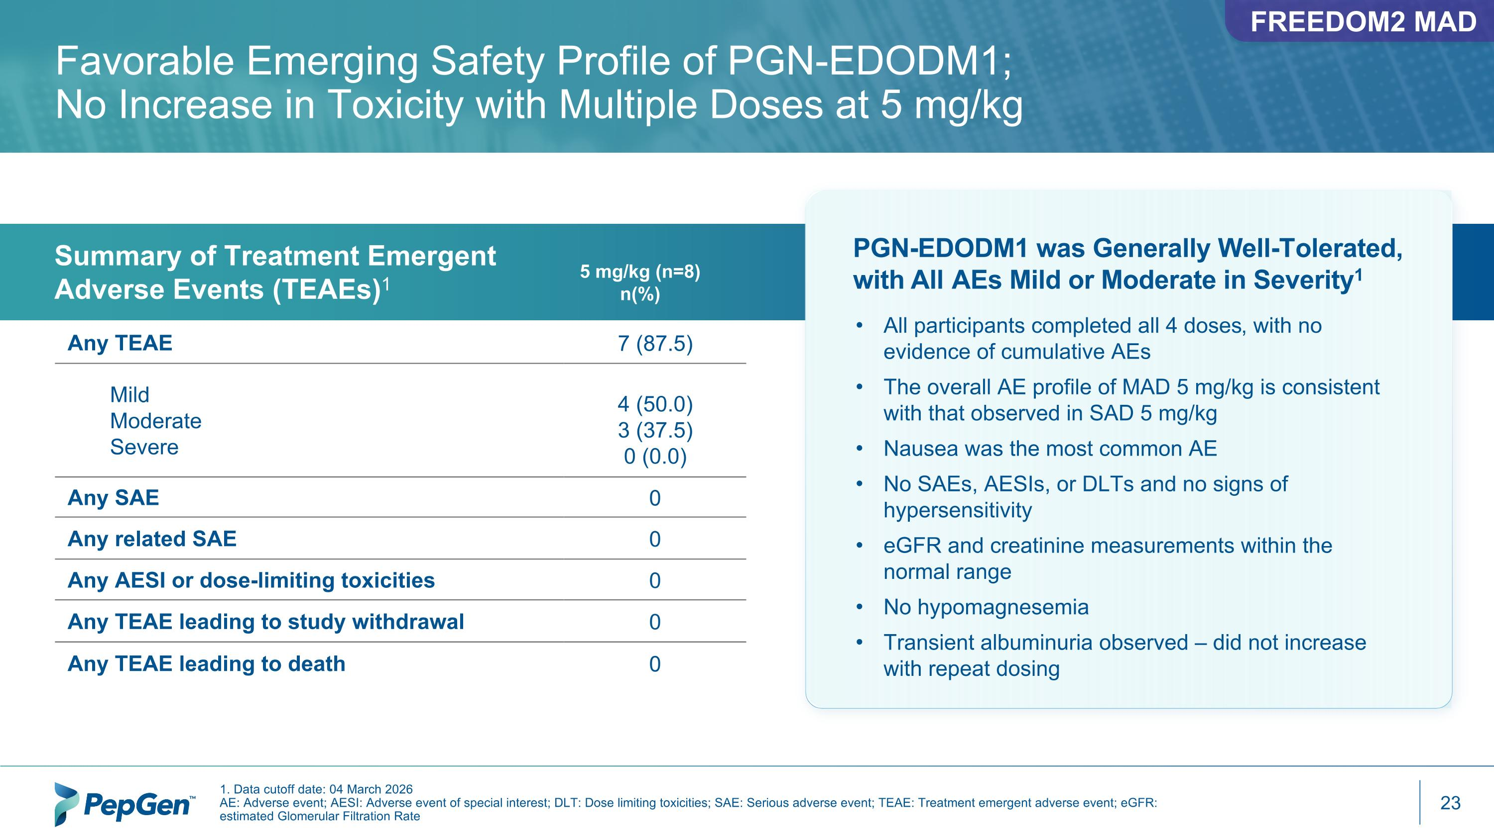
Any TEAE 7 (87.5) Mild Moderate Severe 4 (50.0) 3 (37.5) 0 (0.0) Any SAE 0 Any related SAE 0 Any AESI or dose-limiting toxicities 0 Any TEAE leading to study withdrawal 0 Any TEAE leading to death 0 Favorable Emerging Safety Profile of PGN-EDODM1;?No Increase in Toxicity with Multiple Doses at 5 mg/kg Summary of Treatment Emergent ?Adverse Events (TEAEs)1 1. Data cutoff date: 04 March 2026 AE: Adverse event; AESI: Adverse event of special interest; DLT: Dose limiting toxicities; SAE: Serious adverse event; TEAE: Treatment emergent adverse event; eGFR: estimated Glomerular Filtration Rate 5 mg/kg (n=8) n(%) PGN-EDODM1 was Generally Well-Tolerated, with All AEs Mild or Moderate in Severity1 All participants completed all 4 doses, with no evidence of cumulative AEs The overall AE profile of MAD 5 mg/kg is consistent with that observed in SAD 5 mg/kg Nausea was the most common AE No SAEs, AESIs, or DLTs and no signs of hypersensitivity eGFR and creatinine measurements within the normal range No hypomagnesemia Transient albuminuria observed – did not increase with repeat dosing FREEDOM2 MAD

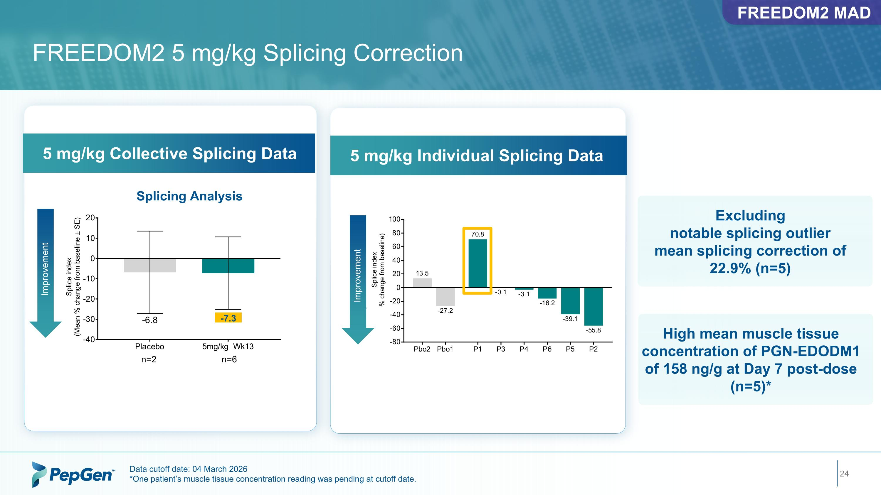
FREEDOM2 5 mg/kg Splicing Correction Data cutoff date: 04 March 2026 *One patient’s muscle tissue concentration reading was pending at cutoff date. Splicing Analysis -7.3 5 mg/kg Collective Splicing Data Excluding notable splicing outlier mean splicing correction of 22.9% (n=5) Improvement FREEDOM2 MAD 5 mg/kg Individual Splicing Data Improvement High mean muscle tissue concentration of PGN-EDODM1 of 158 ng/g at Day 7 post-dose (n=5)*

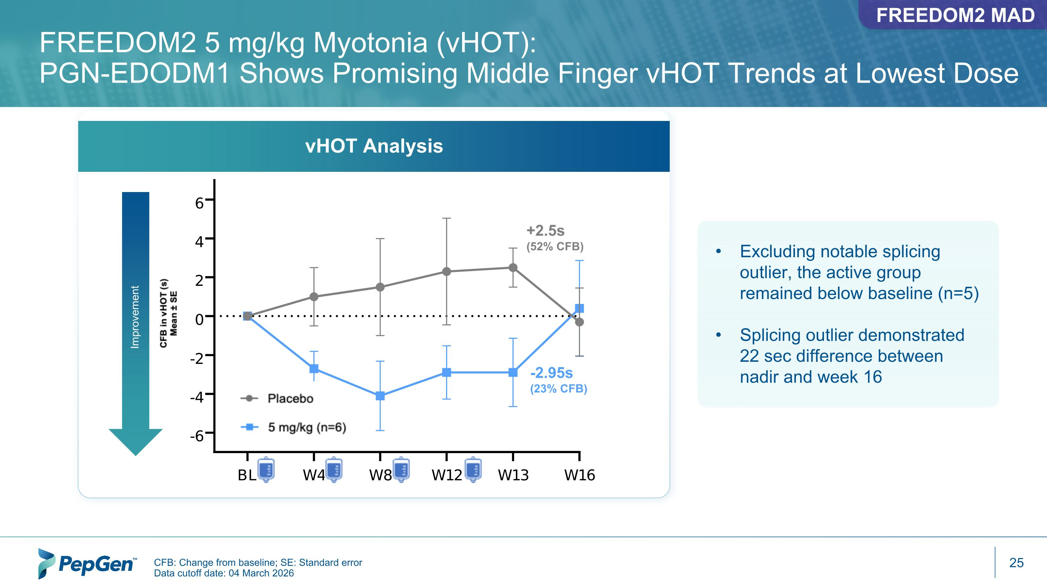
FREEDOM2 5 mg/kg Myotonia (vHOT): ?PGN-EDODM1 Shows Promising Middle Finger vHOT Trends at Lowest Dose Improvement CFB: Change from baseline; SE: Standard error Data cutoff date: 04 March 2026 +2.5s (52% CFB) -2.95s (23% CFB) vHOT Analysis FREEDOM2 MAD Excluding notable splicing outlier, the active group remained below baseline (n=5) Splicing outlier demonstrated 22 sec difference between nadir and week 16

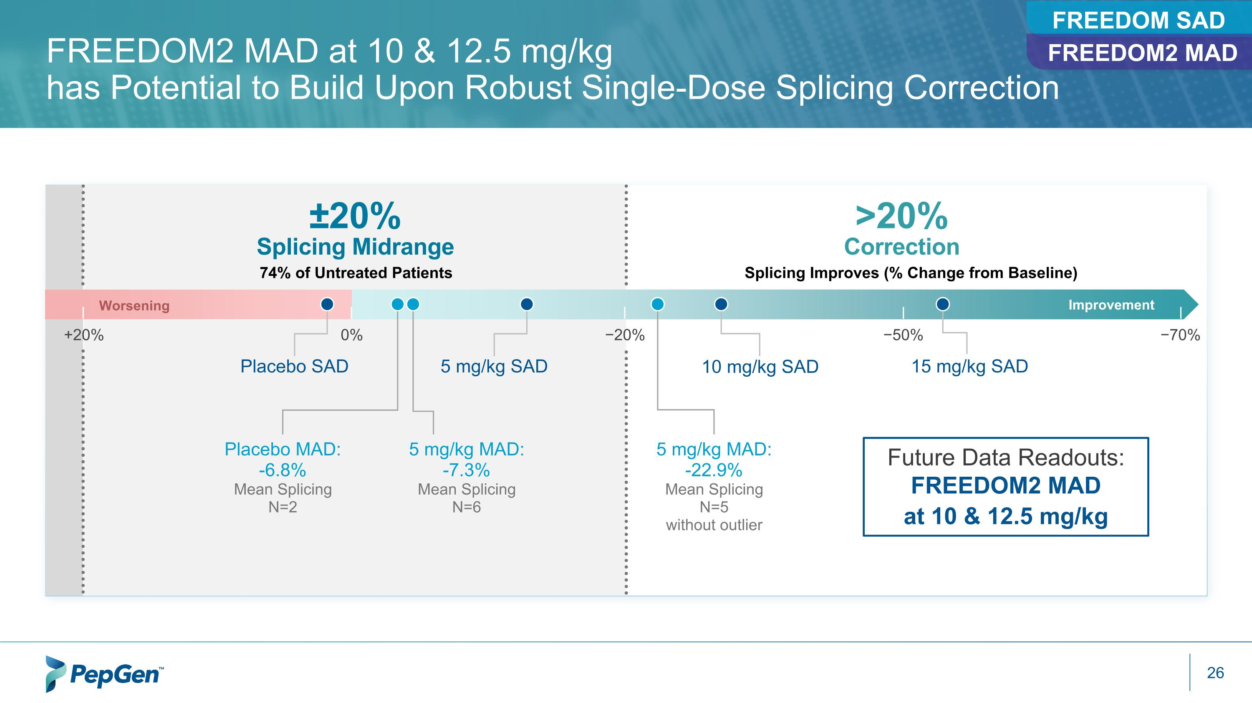
FREEDOM2 MAD at 10 & 12.5 mg/kg ?has Potential to Build Upon Robust Single-Dose Splicing Correction Splicing Improves (% Change from Baseline) >20% ?Correction ±20% ?Splicing Midrange 74% of Untreated Patients +20% 0% −20% −50% −70% Worsening Improvement Placebo MAD: -6.8% Mean Splicing N=2 Placebo SAD 5 mg/kg SAD 10 mg/kg SAD 15 mg/kg SAD 5 mg/kg MAD: -7.3% Mean Splicing N=6 5 mg/kg MAD: -22.9% Mean Splicing N=5 without outlier Future Data Readouts: FREEDOM2 MAD at 10 & 12.5 mg/kg FREEDOM SAD FREEDOM2 MAD

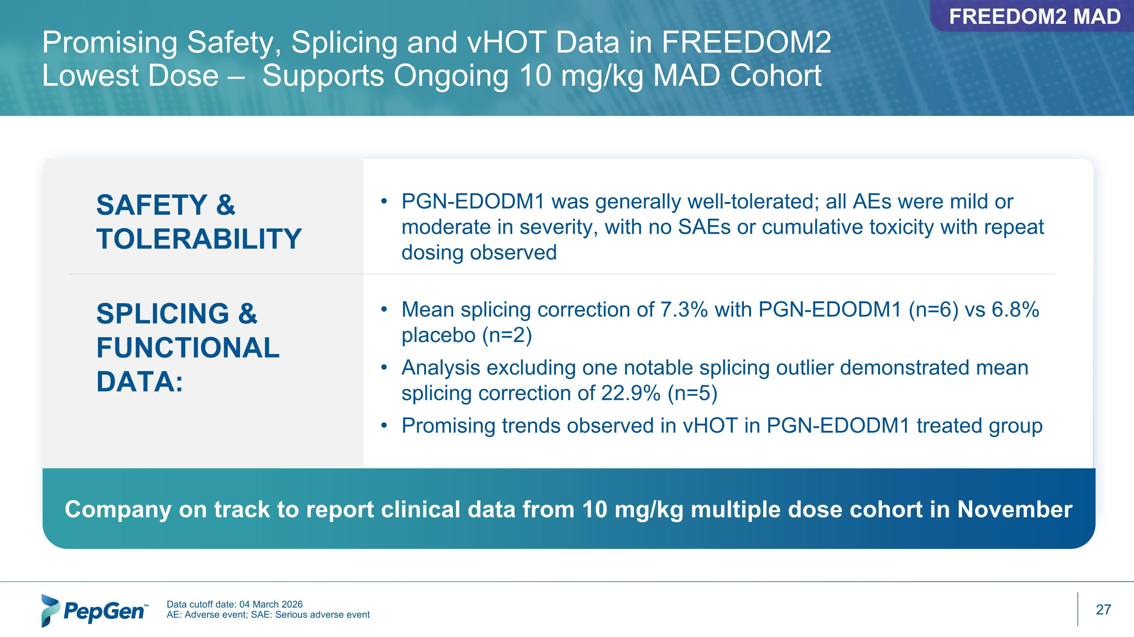
Promising Safety, Splicing and vHOT Data in FREEDOM2 Lowest Dose – Supports Ongoing 10 mg/kg MAD Cohort Data cutoff date: 04 March 2026 AE: Adverse event; SAE: Serious adverse event Company on track to report clinical data from 10 mg/kg multiple dose cohort in November PGN-EDODM1 was generally well-tolerated; all AEs were mild or moderate in severity, with no SAEs or cumulative toxicity with repeat dosing observed SAFETY & TOLERABILITY SPLICING & FUNCTIONAL DATA: Mean splicing correction of 7.3% with PGN-EDODM1 (n=6) vs 6.8% placebo (n=2) Analysis excluding one notable splicing outlier demonstrated mean splicing correction of 22.9% (n=5)​ Promising trends observed in vHOT in PGN-EDODM1 treated group FREEDOM2 MAD

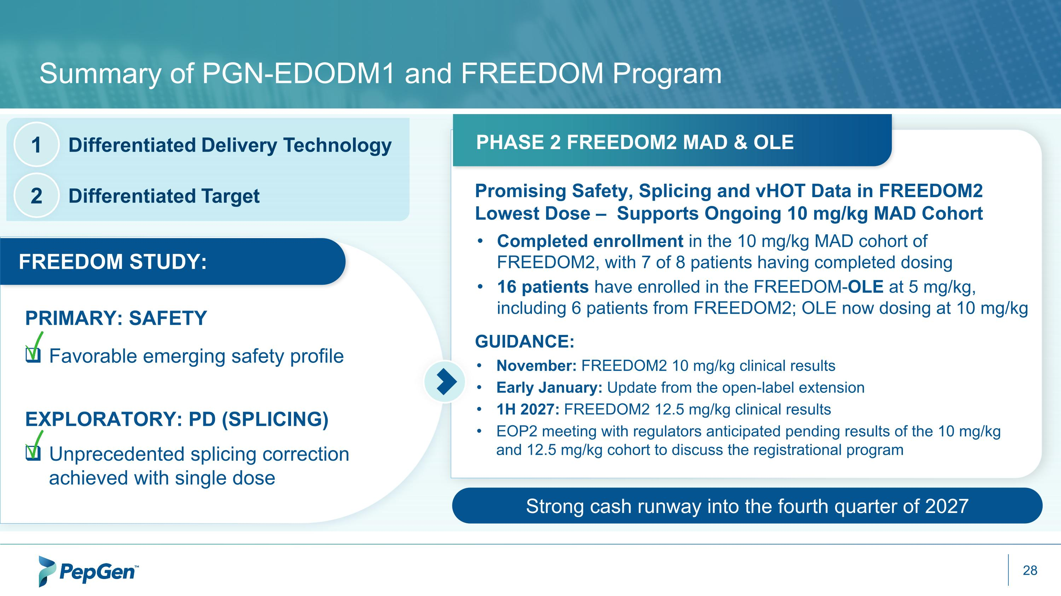
Summary of PGN-EDODM1 and FREEDOM Program Completed enrollment in the 10 mg/kg MAD cohort of FREEDOM2, with 7 of 8 patients having completed dosing 16 patients have enrolled in the FREEDOM-OLE at 5 mg/kg, including 6 patients from FREEDOM2; OLE now dosing at 10 mg/kg November: FREEDOM2 10 mg/kg clinical results Early January: Update from the open-label extension 1H 2027: FREEDOM2 12.5 mg/kg clinical results ​ EOP2 meeting with regulators anticipated pending results of the 10 mg/kg and 12.5 mg/kg cohort to discuss the registrational program Strong cash runway into the fourth quarter of 2027 PHASE 2 FREEDOM2 MAD & OLE Favorable emerging safety profile Unprecedented splicing correction achieved with single dose FREEDOM STUDY: EXPLORATORY: PD (SPLICING) PRIMARY: SAFETY Differentiated Delivery Technology 1 Differentiated Target 2 Promising Safety, Splicing and vHOT Data in FREEDOM2 Lowest Dose – Supports Ongoing 10 mg/kg MAD Cohort GUIDANCE:



PepGen to Advance PGN-EDODM1 into Highest Dose Cohort in Phase 2 FREEDOM2-DM1 Study Following DSMB Review
– DSMB also recommended dose escalation in FREEDOM-OLE from 5 mg/kg to 10 mg/kg –
BOSTON—August 6, 2026-- PepGen Inc. (Nasdaq: PEPG), a clinical-stage biotechnology company advancing the next generation of oligonucleotide therapies with the goal of transforming the treatment of severe neuromuscular and neurological diseases, today announced that an independent Data and Safety Monitoring Board (DSMB) has recommended advancing the ongoing Phase 2 FREEDOM2-DM1 study evaluating PGN-EDODM1 in participants with myotonic dystrophy type 1 (DM1) into the third and highest multiple ascending dose (MAD) cohort of 12.5 mg/kg, with no recommended changes to the study protocol. The DSMB also recommended dose escalation in the open-label extension (OLE) study from 5 mg/kg to 10 mg/kg. Notably, 6 of 8 participants from the 5 mg/kg FREEDOM2 cohort have elected to enroll in the OLE, bringing total OLE enrollment to 16 participants. The recommendation followed a review of available safety data from the fully enrolled 10 mg/kg MAD cohort and the OLE study.
PGN-EDODM1 remains generally well-tolerated, with no serious adverse events or dose-limiting toxicities reported in FREEDOM2 or the OLE to date. Repeat dosing at both the 5 mg/kg and 10 mg/kg dose levels shows no evidence of cumulative toxicity, and no treatment discontinuations were reported in FREEDOM2 or the OLE.
“The DSMB's recommendation to advance FREEDOM2 into the highest planned dose level in the study and escalate dosing in the OLE supports the encouraging safety profile of PGN-EDODM1 following multiple months of treatment,” said James McArthur, PhD, President and Chief Executive Officer of PepGen. “In the FREEDOM2 study, 7 of 8 participants in the 10 mg/kg cohort have now completed dosing. We look forward to reporting additional safety, splicing and functional data from FREEDOM2 as we continue to evaluate the potential of PGN-EDODM1 to address the root cause of disease across multiple organ systems.”
The Company expects to report results from the fully enrolled 10 mg/kg FREEDOM2 cohort in November. Results from the 12.5 mg/kg cohort are expected in the first half of 2027, at which time PepGen plans to engage with regulators in an end of Phase 2 meeting to discuss plans for the registrational program. The Company also expects to provide an update from the OLE study by early January.

About PGN-EDODM1

PGN-EDODM1, PepGen's investigational candidate in development for the treatment of DM1, utilizes the Company's proprietary EDO technology to deliver a therapeutic oligonucleotide that is designed to restore the normal splicing function of MBNL1, a key RNA splicing protein. PGN-EDODM1 addresses the deleterious effects of cytosine-uracil-guanine (CUG) repeat expansion in the dystrophia myotonica protein kinase (DMPK) transcripts which sequester MBNL1, by binding to the pathogenic CUG trinucleotide repeat expansion present in the DMPK transcripts and disrupting the binding between the CUG repeat expansion and MBNL1. PepGen believes this innovative therapeutic approach may have considerable advantages over oligonucleotide modalities that rely on knockdown or degradation of the DMPK transcripts as it will allow the DMPK transcripts to continue to perform their normal function within the cell, while also liberating MBNL1 to correct downstream mis-splicing events. The U.S. Food and Drug Administration has granted PGN-EDODM1 both Orphan Drug and Fast Track Designations for the treatment of patients with DM1. The European Medicines Agency (EMA) has recently granted Orphan Designation for PGN-EDODM1.
About PepGen
PepGen Inc. is a clinical-stage biotechnology company developing the next generation of oligonucleotide therapies with the goal of transforming the treatment of severe neuromuscular and neurological diseases. PepGen’s Enhanced Delivery Oligonucleotide (EDO) platform is founded on over a decade of research and development and leverages cell-penetrating peptides to improve the uptake and activity of conjugated oligonucleotide therapeutics. Using these EDO peptides, the Company is generating a pipeline of oligonucleotide therapeutic candidates designed to target the root cause of serious diseases.
For more information, please visit PepGen.com. Follow PepGen on LinkedIn and X.
Forward-Looking Statements
This press release contains forward-looking statements within the meaning of the Private Securities Litigation Reform Act of 1995, as amended. These statements may be identified by words such as “aims,” “anticipates,” “believes,” “could,” “estimates,” “expects,” “forecasts,” “goal,” “intends,” “may,” “plans,” “possible,” “potential,” “seeks,” “will,” and variations of these words or similar expressions that are intended to identify forward-looking statements. Any such statements in this press release that are not statements of historical fact may be deemed to be forward-looking statements. These forward-looking statements include, without limitation, statements regarding the therapeutic potential and tolerability of PGN-EDODM1, timelines for future data reports from our FREEDOM2-DM1 trial and its open-label extension, and plans to engage with regulators.

Any forward-looking statements in this press release are based on current expectations, estimates and projections only as of the date of this release and are subject to a number of risks and uncertainties that could cause actual results to differ materially and adversely from those set forth in or implied by such forward-looking statements. These risks and uncertainties include, but are not limited to risks related to: delays or failure to successfully initiate or complete our ongoing and planned development activities for PGN-EDODM1; our ability to enroll patients in our clinical trials, including FREEDOM2; that our interpretation of clinical and preclinical study results may be incorrect, or that we may not observe the levels of therapeutic activity in clinical testing that we anticipate based on prior clinical or preclinical results for PGN-EDODM1; that PGN-EDODM1 may not be safe and effective or otherwise demonstrate safety and efficacy in our clinical trials; adverse outcomes from our regulatory interactions, including delays in regulatory review, clearance to proceed or approval by regulatory authorities with respect to our programs, including release of the partial clinical hold or clearance to commence planned clinical studies of our product candidates, or other regulatory feedback requiring modifications to our development programs, including in each case with respect to our PGN-EDODM1 program; changes in regulatory framework that are out of our control; unexpected increases in the expenses associated with our development activities or other events that adversely impact our financial resources and cash runway; and our dependence on third parties for some or all aspects of our product manufacturing, research and preclinical and clinical testing. Additional risks concerning PepGen’s programs and operations are described in our most recent reports filed with the SEC. PepGen explicitly disclaims any obligation to update any forward-looking statements except to the extent required by law.
This release discusses PGN-EDODM1, an investigational therapy that has not been approved for use in any country and is not intended to convey conclusions about its efficacy or safety. There is no guarantee that PGN-EDODM1 or any other investigational therapy will successfully complete clinical development or gain regulatory authority approval.
Investor Contact
Laurence Watts
New Street Investor Relations
Laurence@newstreetir.com

Media Contact
Julia Deutsch
Lyra Strategic Advisory
Jdeutsch@lyraadvisory.com
Source: PepGen Inc.

