UNITED STATES
SECURITIES AND EXCHANGE COMMISSION
WASHINGTON, D.C. 20549

FORM 8-K

CURRENT REPORT
Pursuant to Section 13 or 15(d) of the Securities Exchange Act of 1934
Date of Report (Date of earliest event reported): March 30, 2026

PepGen Inc.
(Exact name of Registrant as Specified in Its Charter)

Delaware |  |  | 001-41374 | 85-3819886
(State or Other Jurisdiction  of Incorporation) |  |  | (Commission File Number) | (IRS Employer  Identification No.)
321 Harrison Avenue
8th Floor
Boston, Massachusetts |  |  |  | 02118
(Address of Principal Executive Offices) |  |  |  | (Zip Code)

Registrant’s Telephone Number, Including Area Code: (781) 797-0979

(Former Name or Former Address, if Changed Since Last Report)

Check the appropriate box below if the Form 8-K filing is intended to simultaneously satisfy the filing obligation of the registrant under any of the following provisions:
☐Written communications pursuant to Rule 425 under the Securities Act (17 CFR 230.425)
☐Soliciting material pursuant to Rule 14a-12 under the Exchange Act (17 CFR 240.14a-12)
☐Pre-commencement communications pursuant to Rule 14d-2(b) under the Exchange Act (17 CFR 240.14d-2(b))
☐Pre-commencement communications pursuant to Rule 13e-4(c) under the Exchange Act (17 CFR 240.13e-4(c))
Securities registered pursuant to Section 12(b) of the Act:
Title of each class |  | Trading  Symbol(s) |  | Name of each exchange on which registered
Common stock, par value $0.0001 per share |  | PEPG |  | Nasdaq Global Select Market
Indicate by check mark whether the registrant is an emerging growth company as defined in Rule 405 of the Securities Act of 1933 (§ 230.405 of this chapter) or Rule 12b-2 of the Securities Exchange Act of 1934 (§ 240.12b-2 of this chapter).
Emerging growth company ☒
If an emerging growth company, indicate by check mark if the registrant has elected not to use the extended transition period for complying with any new or revised financial accounting standards provided pursuant to Section 13(a) of the Exchange Act. ☐

Item 7.01 Regulation FD Disclosure.
On March 30, 2026, PepGen Inc. (the “Company”) issued a press release titled “PepGen Announces Topline Results from Lowest Dose (5 mg/kg) MAD Cohort in the Ongoing Phase 2 FREEDOM2 Study Demonstrating Favorable Safety, Splicing and vHOT Data.” A copy of the press release in connection with the announcement is being furnished as Exhibit 99.1 to this Current Report on Form 8-K.
The information in Item 7.01, in this Current Report on Form 8-K (including Exhibit 99.1 attached hereto) is intended to be furnished and shall not be deemed “filed” for purposes of Section 18 of the Securities Exchange Act of 1934, as amended (the “Exchange Act”) or otherwise subject to the liabilities of that section, nor shall it be deemed incorporated by reference in any filing under the Securities Act of 1933, as amended, or the Exchange Act, except as expressly set forth by specific reference in such filing.

Item 8.01 Other Events.
A copy of the Company’s presentation titled “FREEDOM2-DM1, 5 mg/kg Cohort Data Update”, is filed hereto as Exhibit 99.2 to this Current Report on Form 8-K and is incorporated herein by reference. Representatives of the Company will use the presentation in various meetings with investors from time to time.

Item 9.01 Financial Statements and Exhibits.

(d) Exhibits
Exhibit Number | Description
99.1 | Press Release dated March 30, 2026
99.2 | FREEDOM2-DM1 5 mg/kg MAD Cohort Data Update
104 | Cover Page Interactive Data File (embedded within Inline XBRL document)

SIGNATURES
Pursuant to the requirements of the Securities Exchange Act of 1934, the registrant has duly caused this report to be signed on its behalf by the undersigned hereunto duly authorized.
 |  |  | PEPGEN INC.
Date: | March 30, 2026 | By: | /s/ Noel Donnelly
 |  |  | Noel Donnelly, Chief Financial Officer

PepGen Announces Topline Results from Lowest Dose (5 mg/kg) MAD Cohort in the Ongoing Phase 2 FREEDOM2 Study Demonstrating Favorable Safety, Splicing and vHOT Data
– PGN-EDODM1 was generally well-tolerated with all adverse events mild or moderate and no serious adverse events reported –
– Mean splicing correction of 7.3% observed with PGN-EDODM1 (n=6) versus 6.8% with placebo (n=2); Excluding one outlier patient, treatment group demonstrated mean splicing correction of 22.9% (n=5) –
– Promising trends observed in vHOT in the PGN-EDODM1 treated group –
– Company on track to report clinical data from 10 mg/kg multiple dose cohort in 2H 2026 with sufficient cash expected to fund operations into 2H 2027–
– Conference call scheduled today at 4:30 p.m. ET –
BOSTON—March 30, 2026-- PepGen Inc. (Nasdaq: PEPG), a clinical-stage biotechnology company advancing the next generation of oligonucleotide therapies with the goal of transforming the treatment of severe neuromuscular and neurological diseases, today announced promising clinical data from the 5 mg/kg multiple ascending dose cohort (MAD) of the ongoing Phase 2 FREEDOM2-DM1 trial in patients with myotonic dystrophy type 1 (DM1). The Company believes the totality of safety and efficacy results support the potential of the ongoing 10 mg/kg dose cohort, with clinical results expected in the second half of 2026.
“We are excited to share data from the lowest dose cohort in our multiple ascending dose study of PGN-EDODM1 in patients with DM1,” said Paul Streck, MD, EVP Research and Development. “Overall, we are encouraged by the favorable safety and tolerability profile, and the positive trends exhibited with splicing improvement and vHOT. We look forward to reporting data from the ongoing 10 mg/kg multiple ascending dose cohort of FREEDOM2, which is more than halfway enrolled and remains on track to read out in the second half of this year.”
FREEDOM2 Results for the 5 mg/kg (n=8) Dose Cohort
FREEDOM2 is a Phase 2 MAD, randomized, placebo-controlled clinical trial evaluating PGN-EDODM1 in patients with DM1, with planned dose escalation up to 12.5 mg/kg. The 5 mg/kg cohort enrolled eight patients, who received PGN-EDODM1 or placebo (randomized 6:2) every four weeks over a 12-week period. Key endpoints include safety, splicing correction and functional outcome measures. The data cutoff was March 4, 2026.

Splicing, Muscle Tissue Concentration and Functional Data:
•
Patients (n=6) treated with PGN-EDODM1 at 5 mg/kg demonstrated a mean splicing correction of 7.3%, compared to 6.8% in placebo-treated patients (n=2).
o
Excluding an outlier, patients showed a mean splicing correction of 22.9%. The outlier patient exhibited a worsening in splicing correction (70.8%), reducing the overall group mean to 7.3%.
•
Middle finger vHOT in the treatment group showed a positive trend of improvement versus a worsening observed in the placebo group. Both returned to baseline at Week 16.
•
Mean muscle tissue concentrations of PGN-EDODM1 available in 5 of 6 treated patients were 158 ng/g, as measured approximately one week after the fourth dose in the MAD study; one concentration readout remains pending.
•
No meaningful improvements were observed in 10-meter walk/run test (10MWRT) or handgrip strength at the starting PGN-EDODM1 dose of 5 mg/kg.
Safety and Tolerability Data:
•
PGN-EDODM1 was generally well-tolerated, with no serious adverse events (SAEs), all related treatment emergent adverse events (TEAEs) reported as mild and non-related TEAEs reported as mild or moderate
•
Nausea was the most common TEAE
•
No treatment-related discontinuations
•
No TEAEs related to renal function and no signs of cumulative toxicity
The Company is actively dosing the 10 mg/kg MAD cohort of FREEDOM2, with 5 of 8 patients receiving up to three doses of PGN-EDODM1, and expects to report data in the second half of 2026. In addition, 12 patients have currently enrolled in the open label extension (OLE) at 5 mg/kg, including 5 patients from FREEDOM2.
Conference Call Details
To access the live audio webcast for today’s conference call beginning at 4:30 p.m. ET, please visit PepGen’s investor website at investors.pepgen.com. An archived replay of the webcast will be available on the Company’s website following the event.
About PGN-EDODM1

PGN-EDODM1, PepGen's investigational candidate in development for the treatment of DM1, utilizes the Company's proprietary EDO technology to deliver a therapeutic oligonucleotide that is designed to restore the normal splicing function of MBNL1, a key RNA splicing protein. PGN-EDODM1 addresses the deleterious effects of cytosine-uracil-guanine (CUG) repeat expansion in the dystrophia myotonica protein kinase (DMPK) transcripts which sequester MBNL1, by binding to the pathogenic CUG trinucleotide repeat expansion present in the DMPK transcripts, and disrupting the binding between the CUG repeat expansion and MBNL1. PepGen believes this innovative therapeutic approach may have considerable advantages over oligonucleotide modalities that rely on knockdown or degradation of the DMPK transcripts as it will allow the DMPK transcripts to continue to perform their normal function within the cell, while also liberating MBNL1 to correct downstream mis-splicing events. The U.S. Food and Drug Administration has granted PGN-EDODM1 both Orphan Drug and Fast Track Designations for the treatment of patients with DM1. The European Medicines Agency (EMA) has recently granted Orphan Designation for PGN-EDODM1.
About PepGen
PepGen Inc. is a clinical-stage biotechnology company developing the next generation of oligonucleotide therapies with the goal of transforming the treatment of severe neuromuscular and neurological diseases. PepGen’s Enhanced Delivery Oligonucleotide (EDO) platform is founded on over a decade of research and development and leverages cell-penetrating peptides to improve the uptake and activity of conjugated oligonucleotide therapeutics. Using these EDO peptides, the Company is generating a pipeline of oligonucleotide therapeutic candidates designed to target the root cause of serious diseases.
For more information, please visit PepGen.com. Follow PepGen on LinkedIn and X.
Forward-Looking Statements
This press release contains forward-looking statements within the meaning of the Private Securities Litigation Reform Act of 1995, as amended. These statements may be identified by words such as “aims,” “anticipates,” “believes,” “could,” “estimates,” “expects,” “forecasts,” “goal,” “intends,” “may,” “plans,” “possible,” “potential,” “seeks,” “will,” and variations of these words or similar expressions that are intended to identify forward-looking statements. Any such statements in this press release that are not statements of historical fact may be deemed to be forward-looking statements. These forward-looking statements include, without limitation, statements regarding various data demonstrating promising results that support the safety and clinical potential of PGN-EDODM1 as a

treatment for DM1 and expected timelines for the data report from the 10 mg/kg cohort of our FREEDOM2-DM1 trial , our expected cash runway , the design, initiation and conduct of clinical trials, including expected timelines for our FREEDOM2-DM1 trial, and ongoing and planned regulatory interactions.
Any forward-looking statements in this press release are based on current expectations, estimates and projections only as of the date of this release and are subject to a number of risks and uncertainties that could cause actual results to differ materially and adversely from those set forth in or implied by such forward-looking statements. These risks and uncertainties include, but are not limited to risks related to: delays or failure to successfully initiate or complete our ongoing and planned development activities for PGN-EDODM1; our ability to enroll patients in our clinical trials, including FREEDOM2; that our interpretation of clinical and preclinical study results may be incorrect, or that we may not observe the levels of therapeutic activity in clinical testing that we anticipate based on prior clinical or preclinical results for PGN-EDODM1; that PGN-EDODM1 may not be safe and effective or otherwise demonstrate safety and efficacy in our clinical trials; adverse outcomes from our regulatory interactions, including delays in regulatory review, clearance to proceed or approval by regulatory authorities with respect to our programs, including release of the partial clinical hold or clearance to commence planned clinical studies of our product candidates, or other regulatory feedback requiring modifications to our development programs, including in each case with respect to our FREEDOM2 program; changes in regulatory framework that are out of our control; unexpected increases in the expenses associated with our development activities or other events that adversely impact our financial resources and cash runway; and our dependence on third parties for some or all aspects of our product manufacturing, research and preclinical and clinical testing. Additional risks concerning PepGen’s programs and operations are described in our most recent reports filed with the SEC. PepGen explicitly disclaims any obligation to update any forward-looking statements except to the extent required by law.
This release discusses PGN-EDODM1, an investigational therapy that has not been approved for use in any country, and is not intended to convey conclusions about its efficacy or safety. There is no guarantee that PGN-EDODM1 or any other investigational therapy will successfully complete clinical development or gain regulatory authority approval.
Investor Contact
Laurence Watts
New Street Investor Relations
Laurence@newstreetir.com

Media Contact
Julia Deutsch
Lyra Strategic Advisory
Jdeutsch@lyraadvisory.com
Source: PepGen Inc.

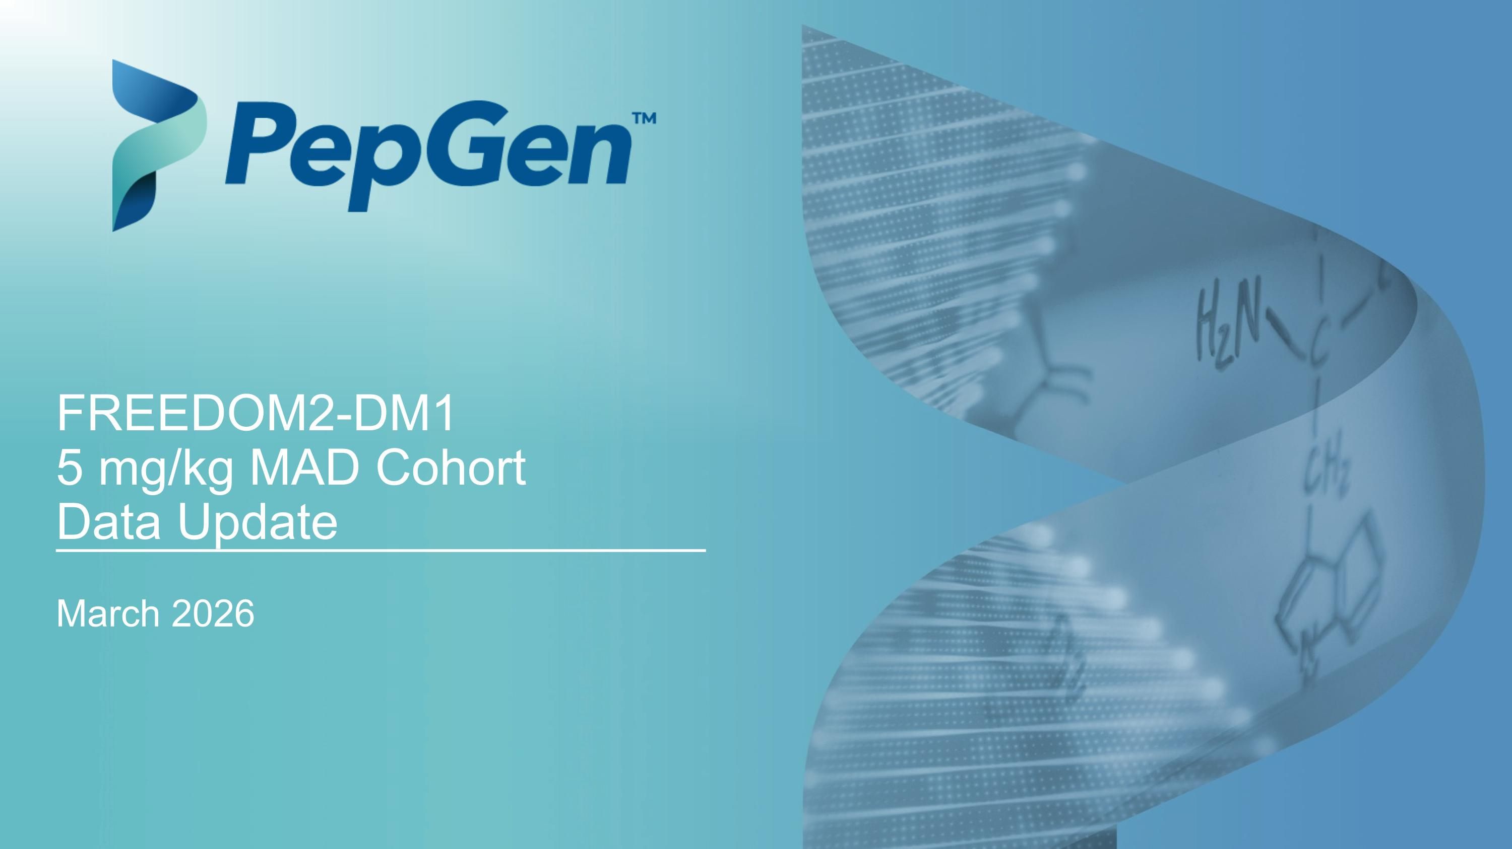
March 2026 FREEDOM2-DM1 ?5 mg/kg MAD Cohort ?Data Update

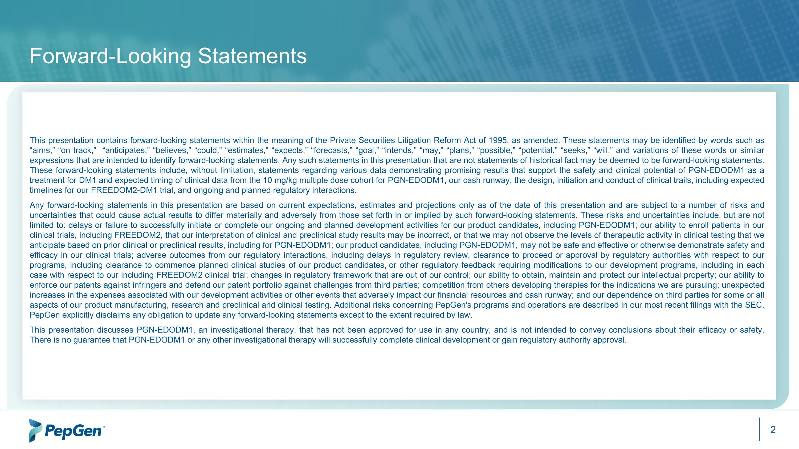
Forward-Looking Statements This presentation contains forward-looking statements within the meaning of the Private Securities Litigation Reform Act of 1995, as amended. These statements may be identified by words such as “aims,” “on track,” “anticipates,” “believes,” “could,” “estimates,” “expects,” “forecasts,” “goal,” “intends,” “may,” “plans,” “possible,” “potential,” “seeks,” “will,” and variations of these words or similar expressions that are intended to identify forward-looking statements. Any such statements in this presentation that are not statements of historical fact may be deemed to be forward-looking statements. These forward-looking statements include, without limitation, statements regarding various data demonstrating promising results that support the safety and clinical potential of PGN-EDODM1 as a treatment for DM1 and expected timing of clinical data from the 10 mg/kg multiple dose cohort for PGN-EDODM1, our cash runway, the design, initiation and conduct of clinical trails, including expected timelines for our FREEDOM2-DM1 trial, and ongoing and planned regulatory interactions. Any forward-looking statements in this presentation are based on current expectations, estimates and projections only as of the date of this presentation and are subject to a number of risks and uncertainties that could cause actual results to differ materially and adversely from those set forth in or implied by such forward-looking statements. These risks and uncertainties include, but are not limited to: delays or failure to successfully initiate or complete our ongoing and planned development activities for our product candidates, including PGN-EDODM1; our ability to enroll patients in our clinical trials, including FREEDOM2, that our interpretation of clinical and preclinical study results may be incorrect, or that we may not observe the levels of therapeutic activity in clinical testing that we anticipate based on prior clinical or preclinical results, including for PGN-EDODM1; our product candidates, including PGN-EDODM1, may not be safe and effective or otherwise demonstrate safety and efficacy in our clinical trials; adverse outcomes from our regulatory interactions, including delays in regulatory review, clearance to proceed or approval by regulatory authorities with respect to our programs, including clearance to commence planned clinical studies of our product candidates, or other regulatory feedback requiring modifications to our development programs, including in each case with respect to our including FREEDOM2 clinical trial; changes in regulatory framework that are out of our control; our ability to obtain, maintain and protect our intellectual property; our ability to enforce our patents against infringers and defend our patent portfolio against challenges from third parties; competition from others developing therapies for the indications we are pursuing; unexpected increases in the expenses associated with our development activities or other events that adversely impact our financial resources and cash runway; and our dependence on third parties for some or all aspects of our product manufacturing, research and preclinical and clinical testing. Additional risks concerning PepGen's programs and operations are described in our most recent filings with the SEC. PepGen explicitly disclaims any obligation to update any forward-looking statements except to the extent required by law. This presentation discusses PGN-EDODM1, an investigational therapy, that has not been approved for use in any country, and is not intended to convey conclusions about their efficacy or safety. There is no guarantee that PGN-EDODM1 or any other investigational therapy will successfully complete clinical development or gain regulatory authority approval.


Agenda James McArthur, PhD President and Chief Executive Officer Key Takeaways, Platform, Closing Remarks, and Q&A Paul Streck, MD, MBA Head of R&D FREEDOM2 Clinical Trial Design, Clinical Data, and Q&A


Myotonic Dystrophy Type 1 ?Overview and EDO Platform

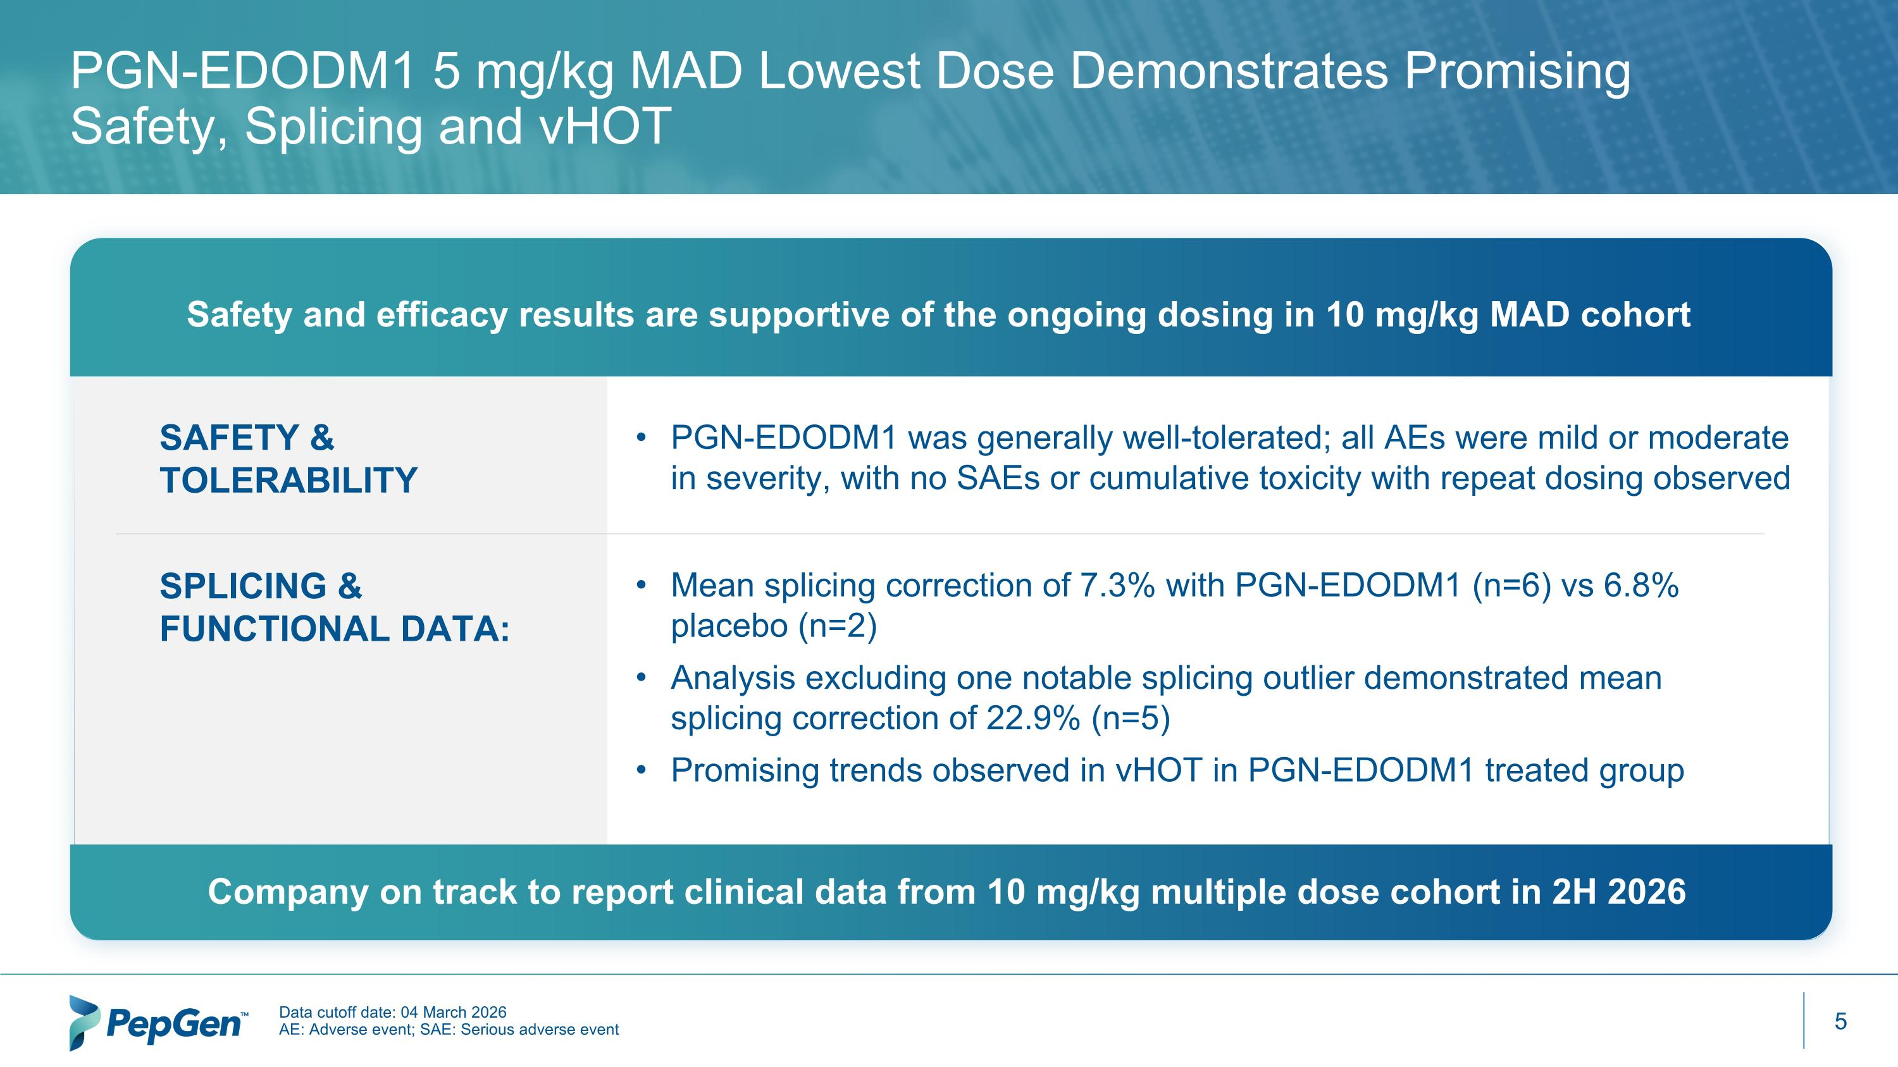
Safety and efficacy results are supportive of the ongoing dosing in 10 mg/kg MAD cohort PGN-EDODM1 5 mg/kg MAD Lowest Dose Demonstrates Promising Safety, Splicing and vHOT Company on track to report clinical data from 10 mg/kg multiple dose cohort in 2H 2026 Data cutoff date: 04 March 2026 AE: Adverse event; SAE: Serious adverse event PGN-EDODM1 was generally well-tolerated; all AEs were mild or moderate in severity, with no SAEs or cumulative toxicity with repeat dosing observed SAFETY & TOLERABILITY SPLICING & FUNCTIONAL DATA: Mean splicing correction of 7.3% with PGN-EDODM1 (n=6) vs 6.8% placebo (n=2) Analysis excluding one notable splicing outlier demonstrated mean splicing correction of 22.9% (n=5)​ Promising trends observed in vHOT in PGN-EDODM1 treated group

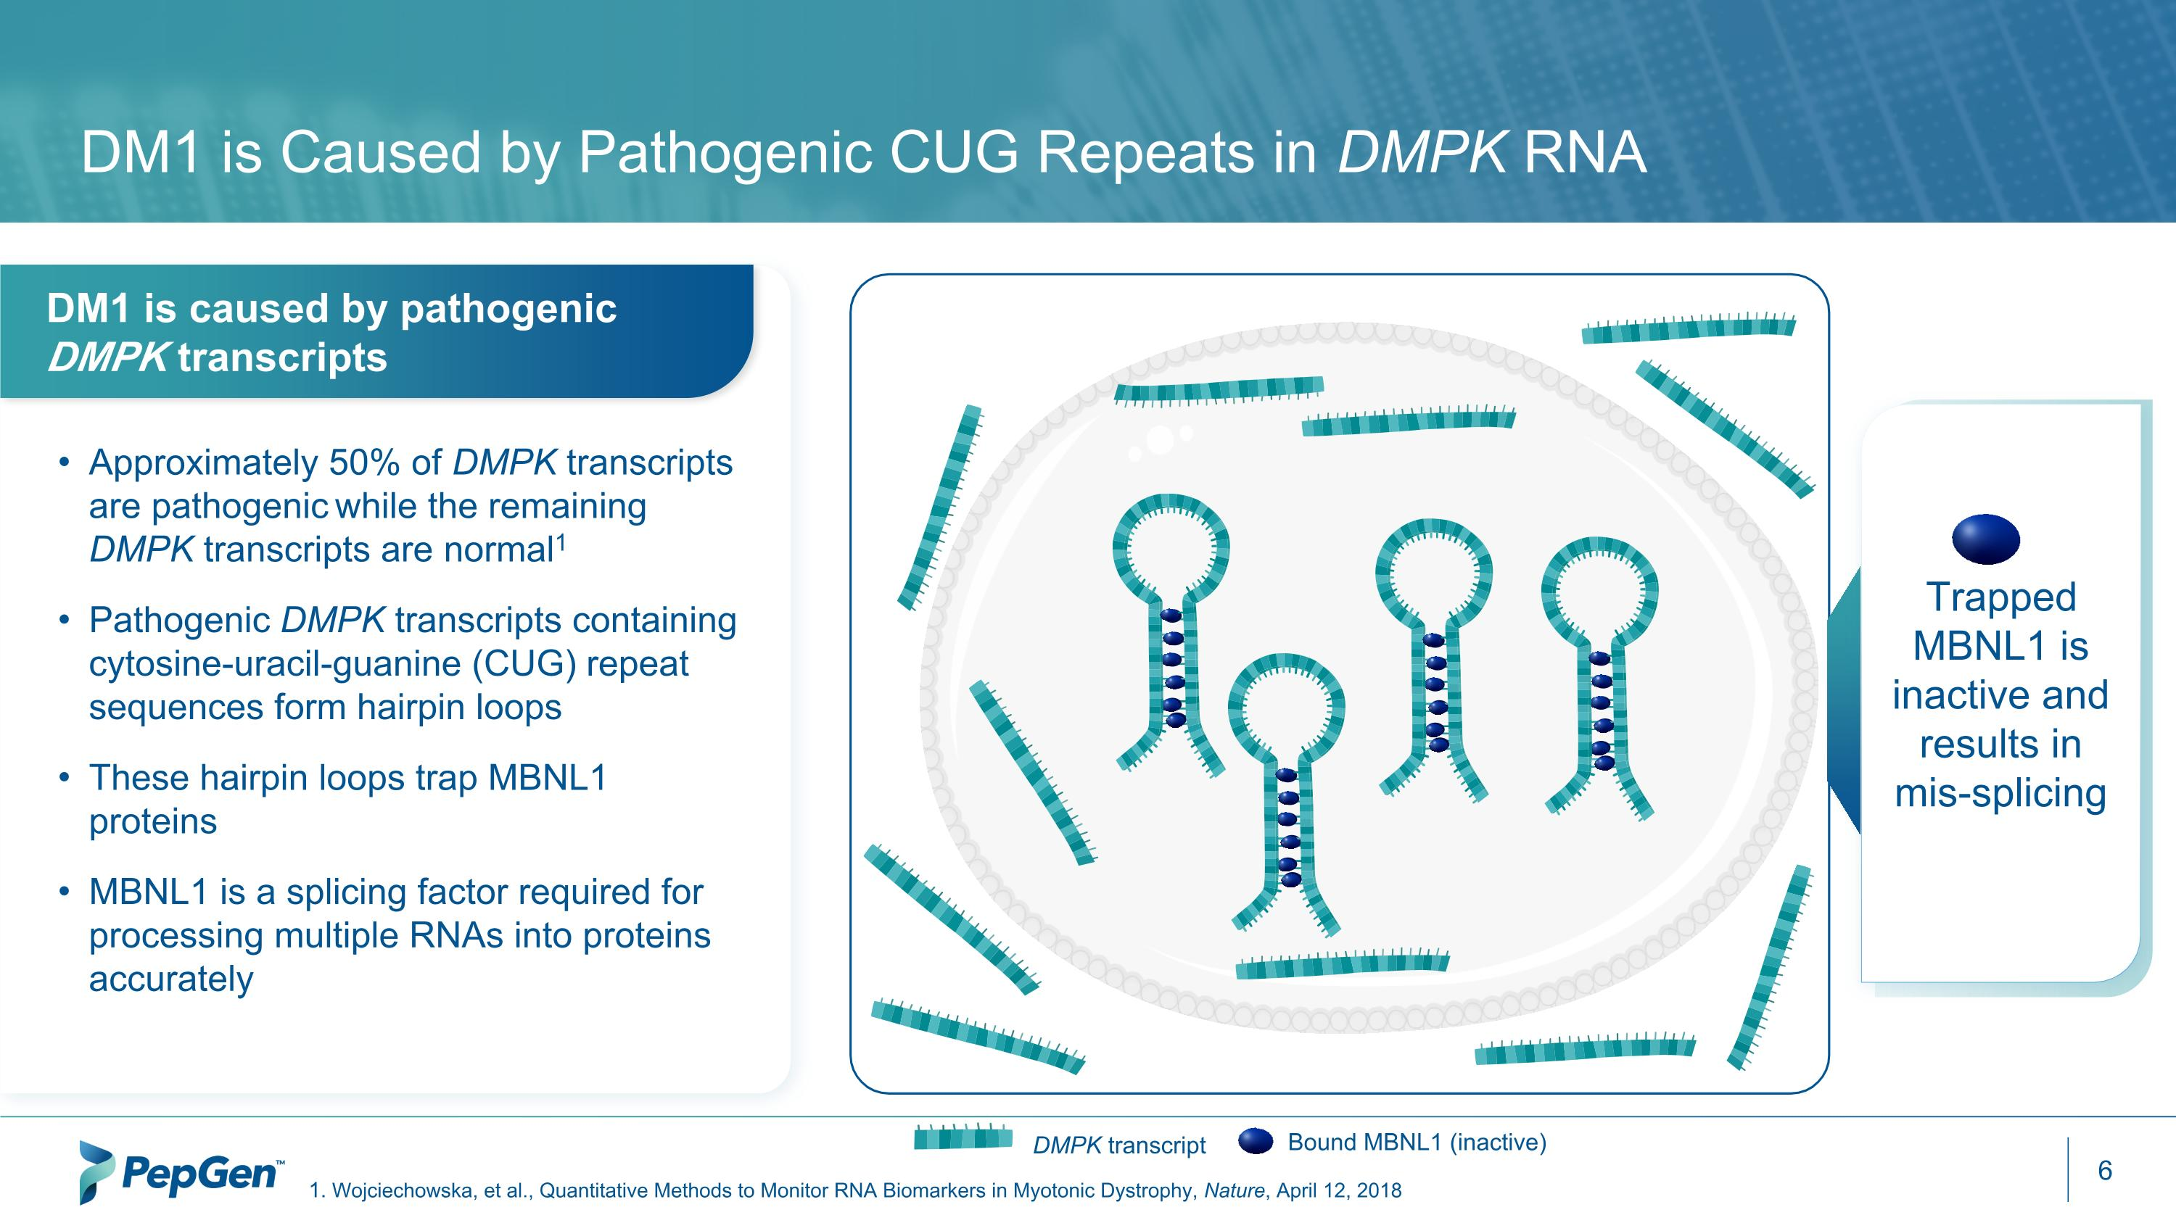
DM1 is Caused by Pathogenic CUG Repeats in DMPK RNA DM1 is caused by pathogenic DMPK transcripts Approximately 50% of DMPK transcripts are pathogenic while the remaining DMPK transcripts are normal1 Pathogenic DMPK transcripts containing cytosine-uracil-guanine (CUG) repeat sequences form hairpin loops These hairpin loops trap MBNL1 proteins MBNL1 is a splicing factor required for processing multiple RNAs into proteins accurately Bound MBNL1 (inactive) DMPK transcript Trapped MBNL1 is inactive and results in mis-splicing Wojciechowska, et al., Quantitative Methods to Monitor RNA Biomarkers in Myotonic Dystrophy, Nature, April 12, 2018

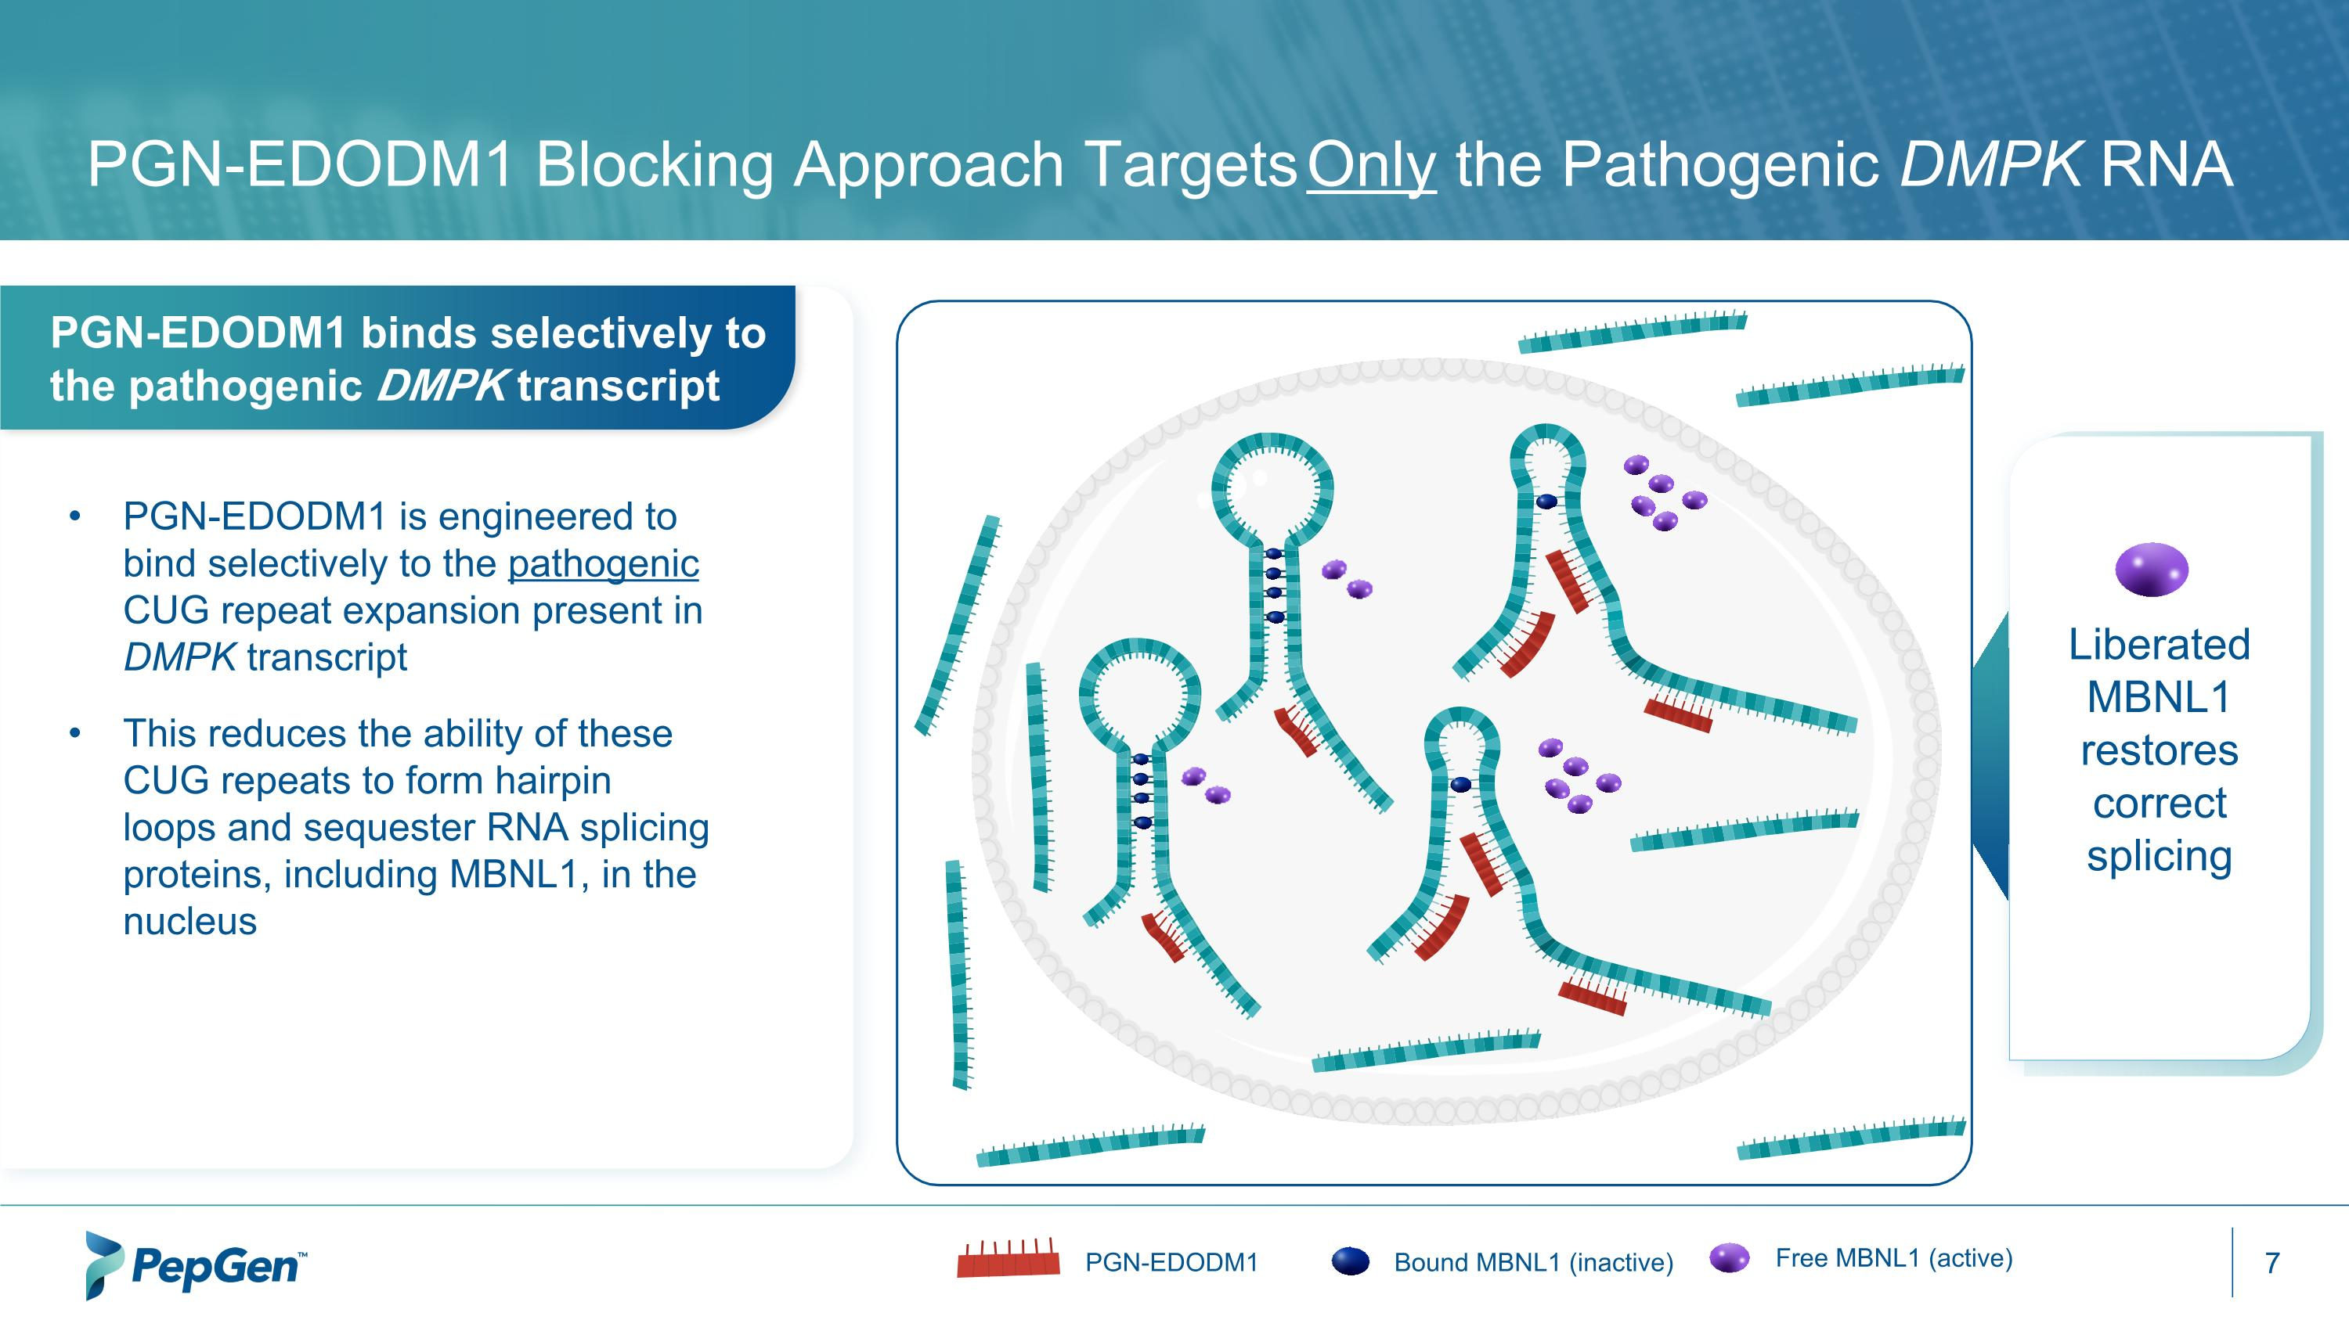
PGN-EDODM1 Blocking Approach Targets Only the Pathogenic DMPK RNA PGN-EDODM1 is engineered to bind selectively to the pathogenic CUG repeat expansion present in DMPK transcript This reduces the ability of these CUG repeats to form hairpin loops and sequester RNA splicing proteins, including MBNL1, in the nucleus Bound MBNL1 (inactive) Free MBNL1 (active) PGN-EDODM1 PGN-EDODM1 binds selectively to the pathogenic DMPK transcript Liberated MBNL1 restores correct splicing

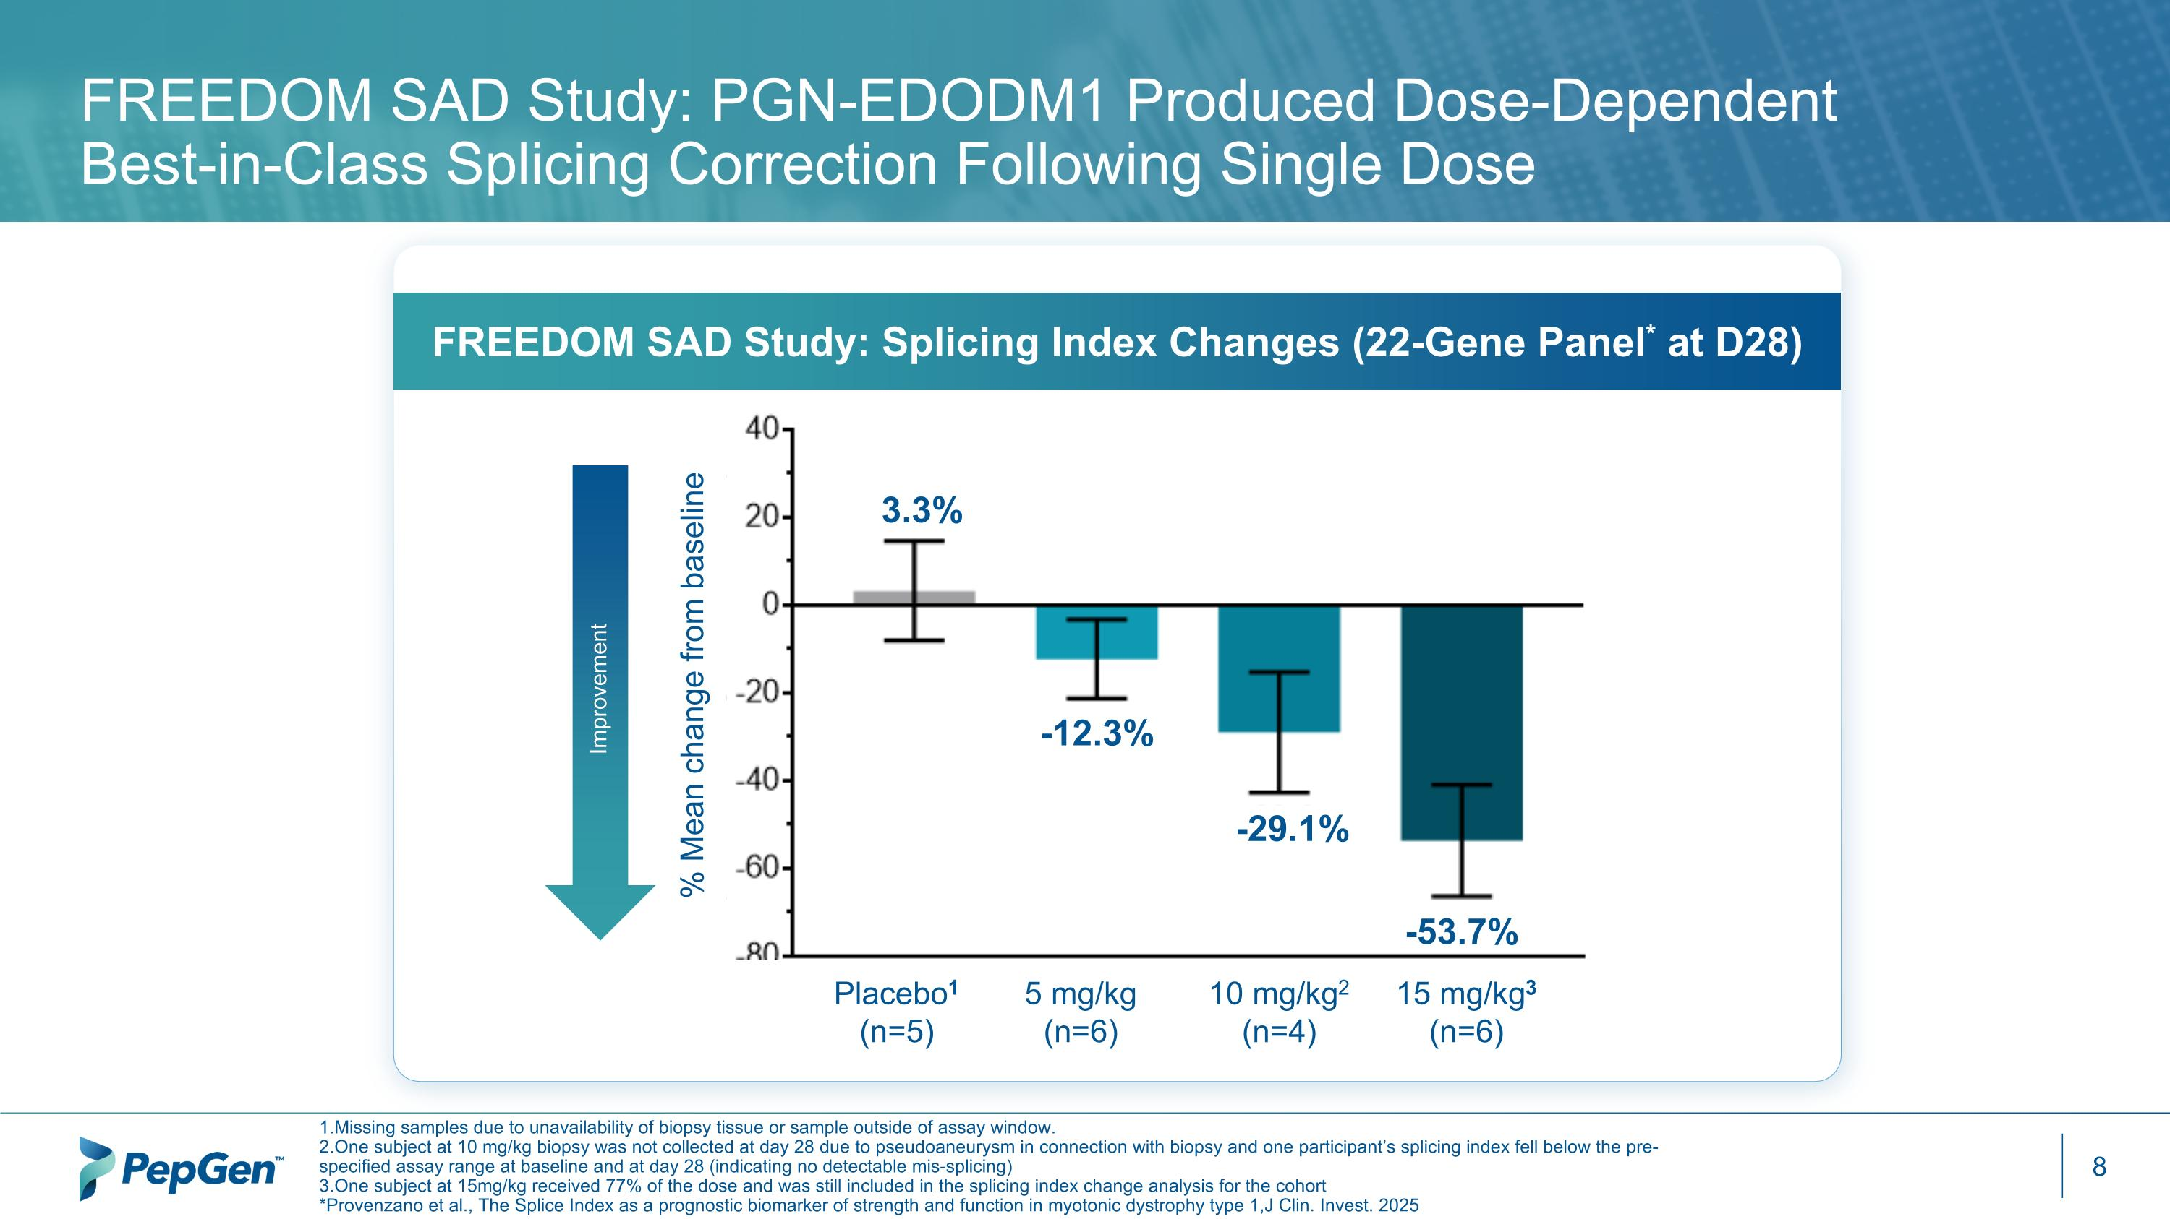
FREEDOM SAD Study: PGN-EDODM1 Produced Dose-Dependent Best-in-Class Splicing Correction Following Single Dose 1.Missing samples due to unavailability of biopsy tissue or sample outside of assay window. 2.One subject at 10 mg/kg biopsy was not collected at day 28 due to pseudoaneurysm in connection with biopsy and one participant’s splicing index fell below the pre-specified assay range at baseline and at day 28 (indicating no detectable mis-splicing) 3.One subject at 15mg/kg received 77% of the dose and was still included in the splicing index change analysis for the cohort *Provenzano et al., The Splice Index as a prognostic biomarker of strength and function in myotonic dystrophy type 1,J Clin. Invest. 2025 FREEDOM SAD Study: Splicing Index Changes (22-Gene Panel* at D28) Improvement -53.7% -29.1% 3.3% -12.3% % Mean change from baseline Placebo1 (n=5) 5 mg/kg (n=6) 10 mg/kg2 (n=4) 15 mg/kg3 (n=6)


FREEDOM2-DM1 ?5 mg/kg MAD Cohort? ?Overview and Results

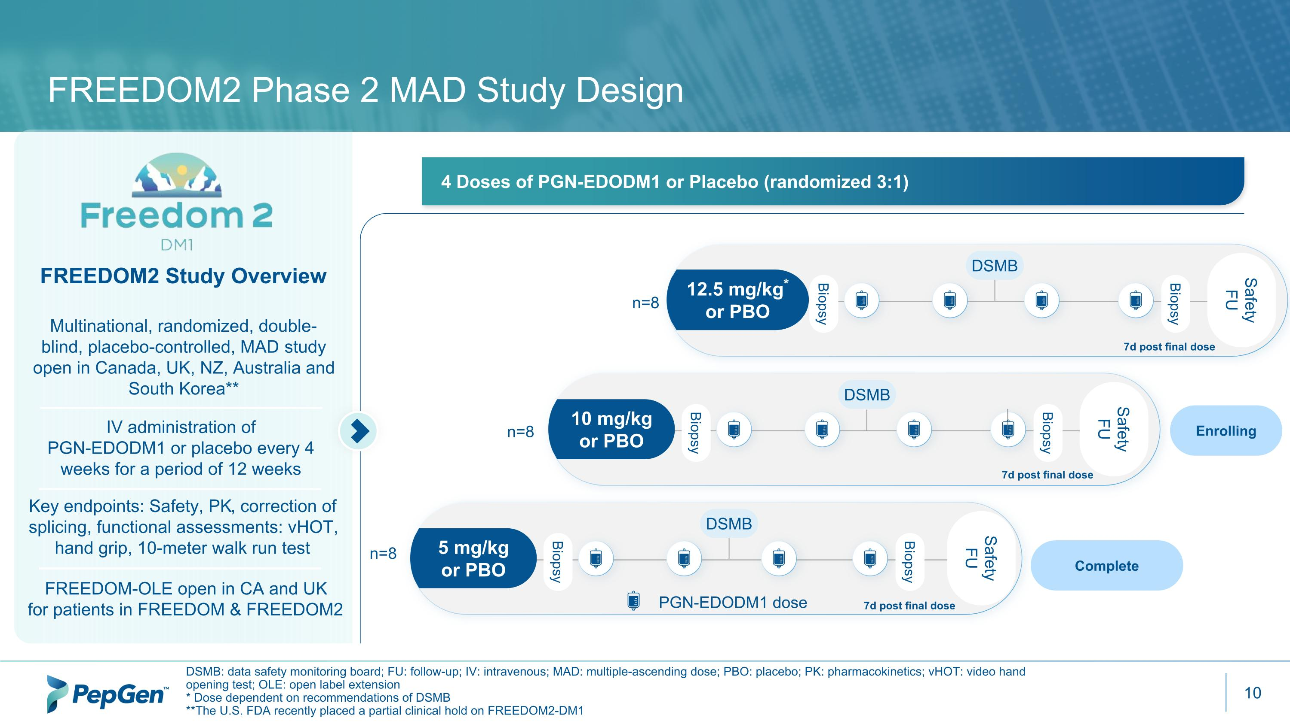
FREEDOM2 Phase 2 MAD Study Design DSMB: data safety monitoring board; FU: follow-up; IV: intravenous; MAD: multiple-ascending dose; PBO: placebo; PK: pharmacokinetics; vHOT: video hand opening test; OLE: open label extension * Dose dependent on recommendations of DSMB **The U.S. FDA recently placed a partial clinical hold on FREEDOM2-DM1 FREEDOM2 Study Overview Multinational, randomized, double-blind, placebo-controlled, MAD study open in Canada, UK, NZ, Australia and South Korea** IV administration of ?PGN-EDODM1 or placebo every 4 weeks for a period of 12 weeks FREEDOM-OLE open in CA and UK for patients in FREEDOM & FREEDOM2 4 Doses of PGN-EDODM1 or Placebo (randomized 3:1) n=8 Safety FU Biopsy Biopsy 12.5 mg/kg* or PBO DSMB Safety FU Biopsy Biopsy 10 mg/kg or PBO DSMB Biopsy Biopsy 5 mg/kg or PBO DSMB n=8 n=8 Safety FU Complete PGN-EDODM1 dose Key endpoints: Safety, PK, correction of splicing, functional assessments: vHOT, hand grip, 10-meter walk run test Enrolling 7d post final dose 7d post final dose 7d post final dose

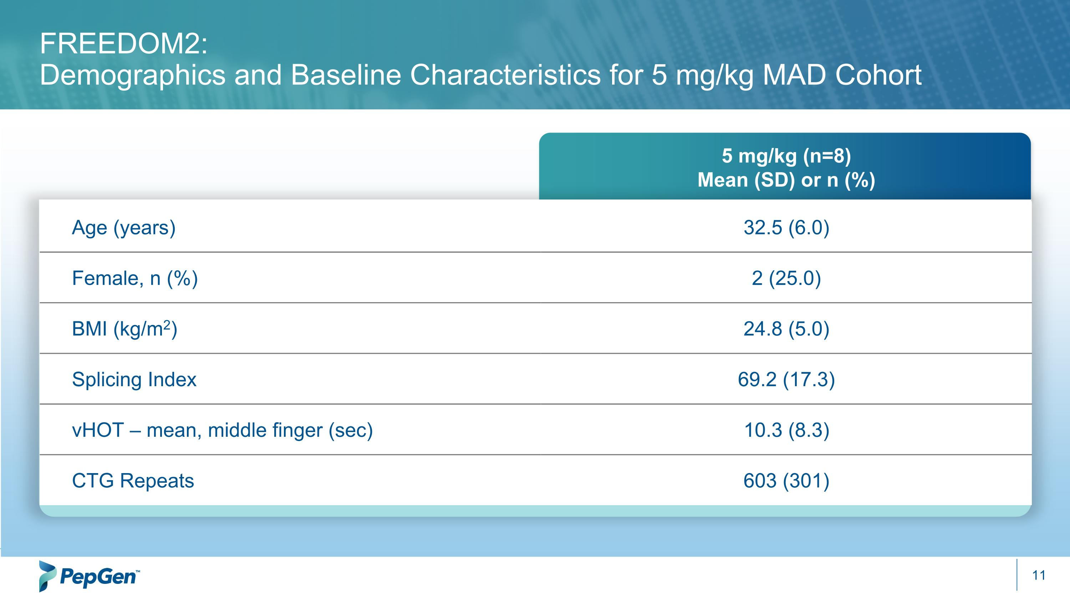
5 mg/kg (n=8) Mean (SD) or n (%) Age (years) 32.5 (6.0) Female, n (%) 2 (25.0) BMI (kg/m2) 24.8 (5.0) Splicing Index 69.2 (17.3) vHOT – mean, middle finger (sec) 10.3 (8.3) CTG Repeats 603 (301) FREEDOM2: ?Demographics and Baseline Characteristics for 5 mg/kg MAD Cohort

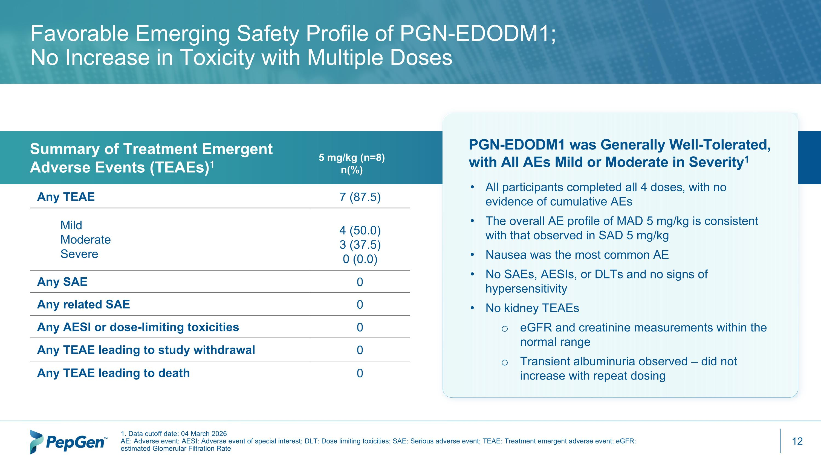
Any TEAE 7 (87.5) Mild Moderate Severe 4 (50.0) 3 (37.5) 0 (0.0) Any SAE 0 Any related SAE 0 Any AESI or dose-limiting toxicities 0 Any TEAE leading to study withdrawal 0 Any TEAE leading to death 0 Favorable Emerging Safety Profile of PGN-EDODM1;?No Increase in Toxicity with Multiple Doses Summary of Treatment Emergent ?Adverse Events (TEAEs)1 1. Data cutoff date: 04 March 2026 AE: Adverse event; AESI: Adverse event of special interest; DLT: Dose limiting toxicities; SAE: Serious adverse event; TEAE: Treatment emergent adverse event; eGFR: estimated Glomerular Filtration Rate 5 mg/kg (n=8) n(%) PGN-EDODM1 was Generally Well-Tolerated, with All AEs Mild or Moderate in Severity1 All participants completed all 4 doses, with no evidence of cumulative AEs The overall AE profile of MAD 5 mg/kg is consistent with that observed in SAD 5 mg/kg Nausea was the most common AE No SAEs, AESIs, or DLTs and no signs of hypersensitivity No kidney TEAEs eGFR and creatinine measurements within the normal range Transient albuminuria observed – did not increase with repeat dosing

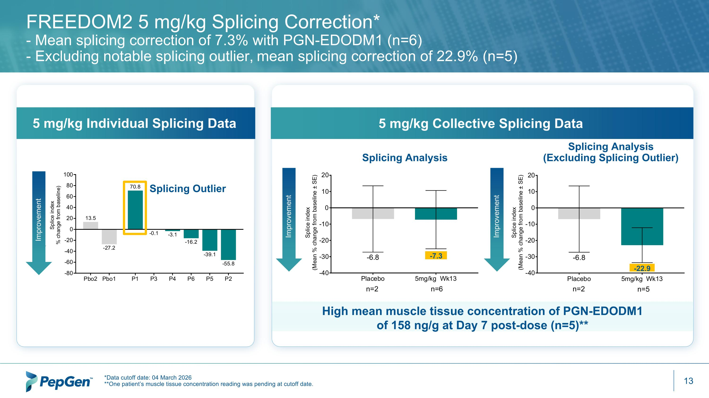
FREEDOM2 5 mg/kg Splicing Correction*?- Mean splicing correction of 7.3% with PGN-EDODM1 (n=6) ?- Excluding notable splicing outlier, mean splicing correction of 22.9% (n=5)​ *Data cutoff date: 04 March 2026 **One patient’s muscle tissue concentration reading was pending at cutoff date. Splicing Analysis -7.3 Splicing Analysis (Excluding Splicing Outlier) -22.9 5 mg/kg Individual Splicing Data 5 mg/kg Collective Splicing Data Splicing Outlier High mean muscle tissue concentration of PGN-EDODM1 of 158 ng/g at Day 7 post-dose (n=5)** Improvement Improvement Improvement

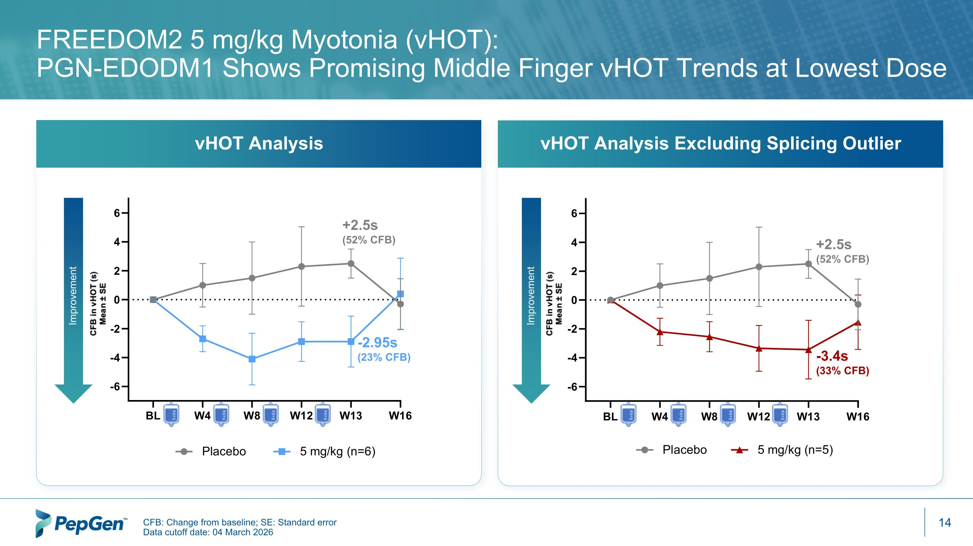
FREEDOM2 5 mg/kg Myotonia (vHOT): ?PGN-EDODM1 Shows Promising Middle Finger vHOT Trends at Lowest Dose Improvement Improvement CFB: Change from baseline; SE: Standard error Data cutoff date: 04 March 2026 +2.5s (52% CFB) -2.95s (23% CFB) +2.5s (52% CFB) -3.4s (33% CFB) vHOT Analysis Excluding Splicing Outlier vHOT Analysis

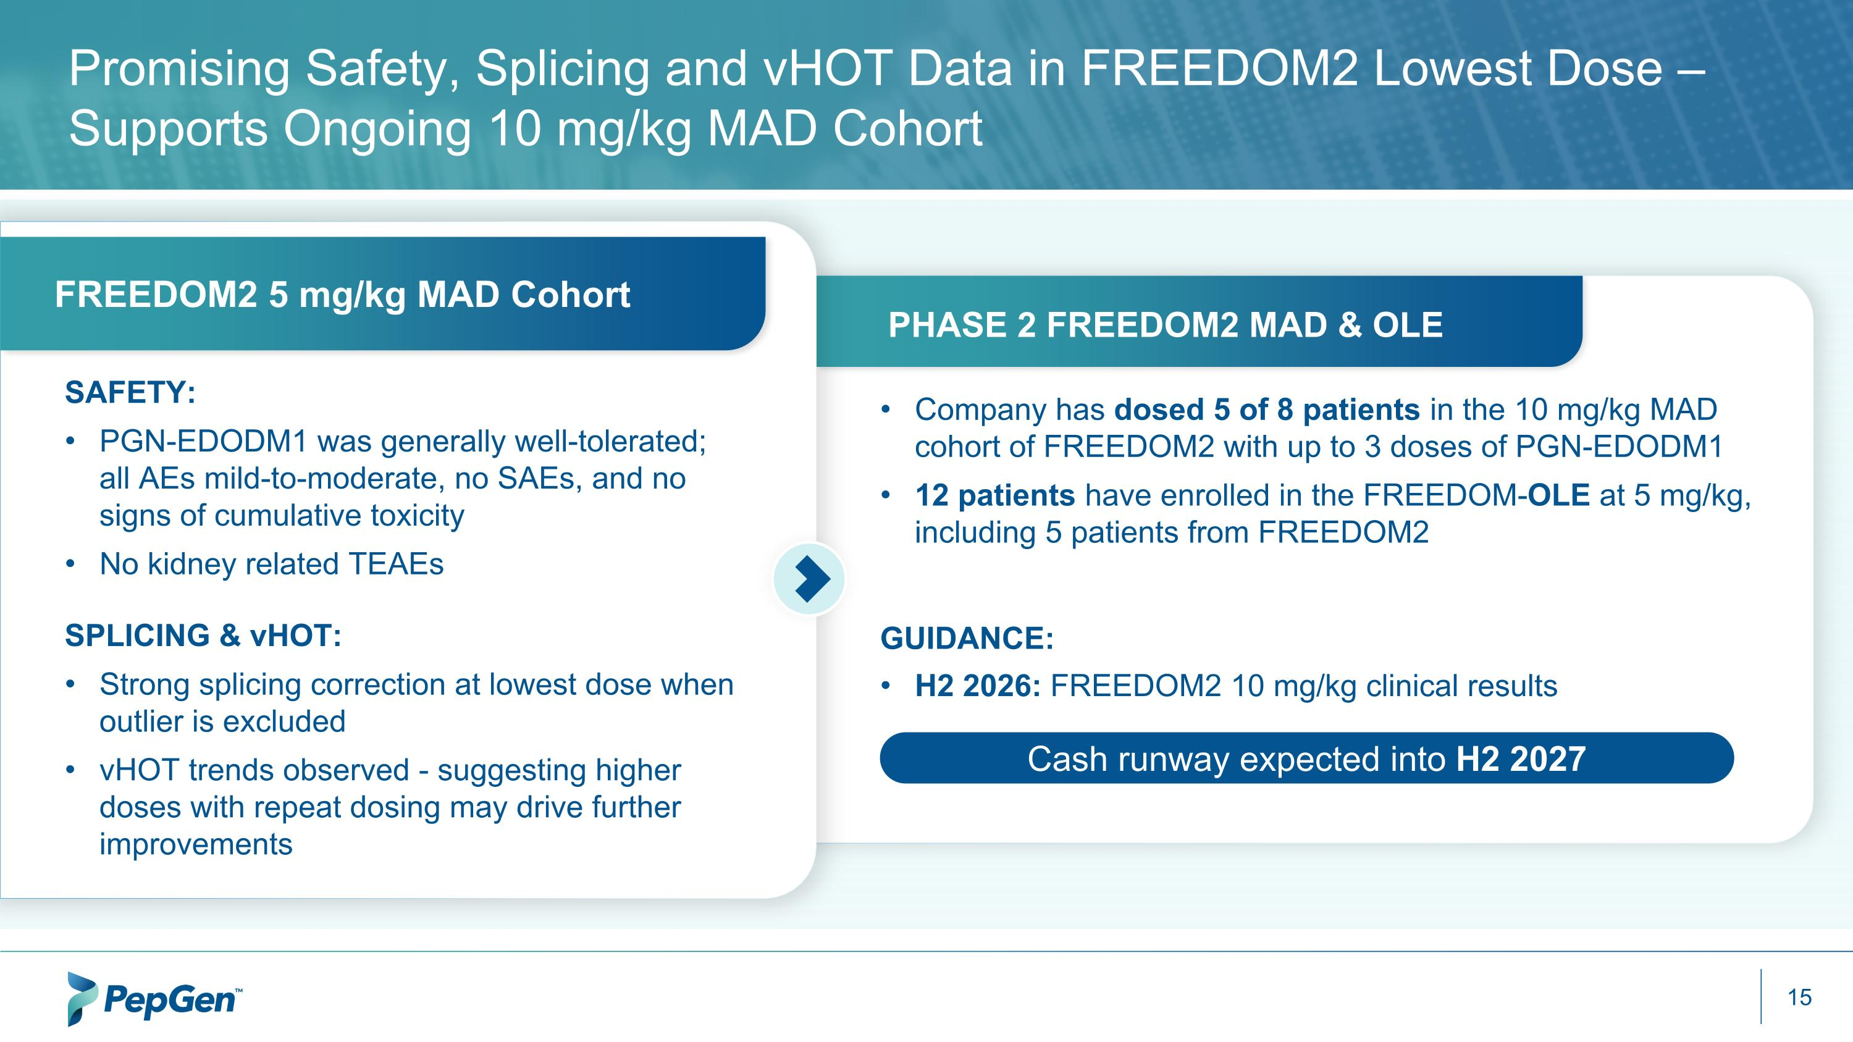
Promising Safety, Splicing and vHOT Data in FREEDOM2 Lowest Dose – Supports Ongoing 10 mg/kg MAD Cohort SAFETY: PGN-EDODM1 was generally well-tolerated; all AEs mild-to-moderate, no SAEs, and no signs of cumulative toxicity​ No kidney related TEAEs SPLICING & vHOT: Strong splicing correction at lowest dose when outlier is excluded​ vHOT trends observed - suggesting higher doses with repeat dosing may drive further improvements​ Company has dosed 5 of 8 patients in the 10 mg/kg MAD cohort of FREEDOM2 with up to 3 doses of PGN-EDODM1 12 patients have enrolled in the FREEDOM-OLE at 5 mg/kg, including 5 patients from FREEDOM2 GUIDANCE: H2 2026: FREEDOM2 10 mg/kg clinical results ​ Cash runway expected into H2 2027 PHASE 2 FREEDOM2 MAD & OLE FREEDOM2 5 mg/kg MAD Cohort

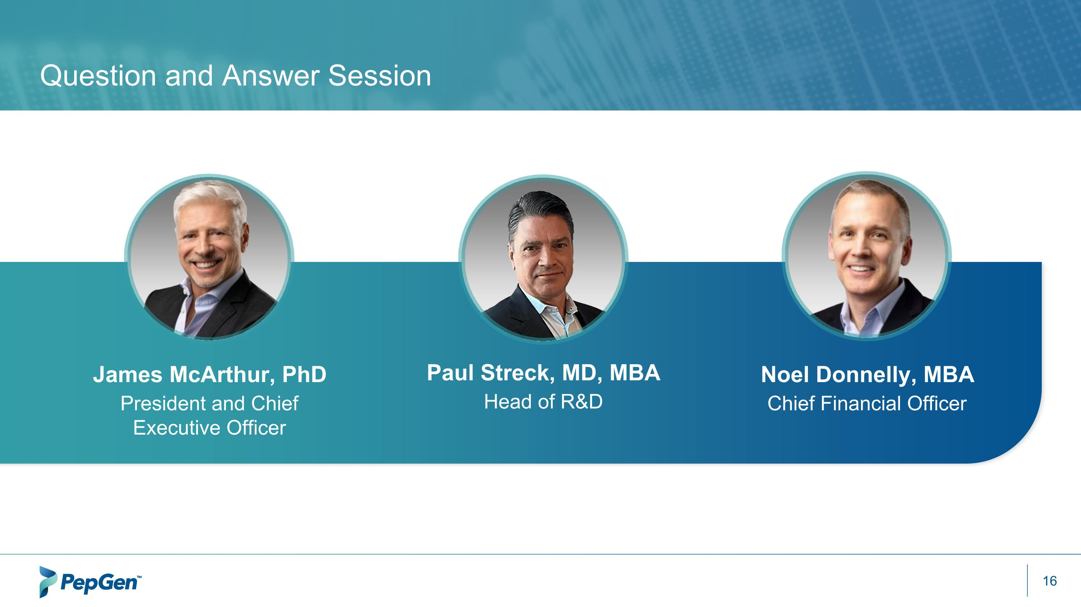
Question and Answer Session James McArthur, PhD President and Chief Executive Officer Paul Streck, MD, MBA Head of R&D Noel Donnelly, MBA Chief Financial Officer



